ONLINE APPENDIX

The Effect of Racial and Ethnic Attitudes on Asian Identity in the U.S

# Data

Figure A.1: Examples of an Implicit Association Test

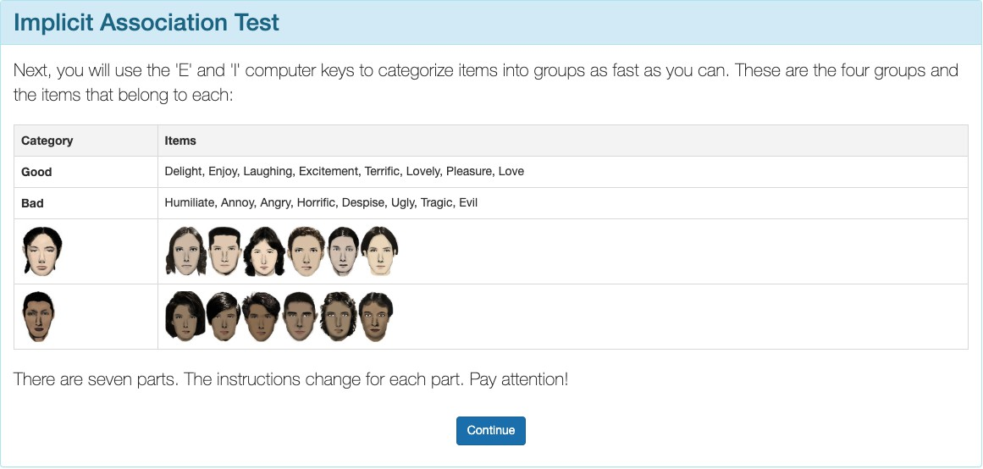

Here are a few examples of what a respondent would see on an implicit association test.

# Tables

Table A.1: Asian Identity Models - All Generations (with Marginal Effects)

|  |  |  |  |
| --- | --- | --- | --- |
|  | LPM | Logit (ME) | Probit (ME) |
| Bias | -0.0890*** | -0.0896*** | -0.1046*** |
|  | (0.0308) | (0.2704) | (0.2704) |
| Female | -0.0095* | -0.0103** | -0.0121** |
|  | (0.0050) | (0.0422) | (0.0422) |
| College Graduate: Mother | 0.0087 | 0.0097 | 0.0114 |
|  | (0.0067) | (0.0571) | (0.0571) |
| College Graduate: Father | 0.0148** | 0.0153*** | 0.0178*** |
|  | (0.0061) | (0.0486) | (0.0486) |
| Mean | 0.65 | 0.65 | 0.65 |
| Observations | 129,078 | 129,078 | 129,078 |

*p < 0.1, ** p < 0.05, *** p < 0.01

1 Linear Probability Model (LPM) shows coefficients. Logit and Probit show marginal effects.

2 All models include region ! year fixed effects.

3 Standard errors clustered at state level.

4 ME = Marginal Effects calculated at sample means.

Table A.2: Asian Identity Models - First Generation (with Marginal Effects)

Model Type LPM Logit (ME) Probit (ME)

|  |  |  |  |  |  |  |  |  |
| --- | --- | --- | --- | --- | --- | --- | --- | --- |
|  | | | LPM |  | Logit (ME) |  | Probit (ME) |  |
|  | Bias |  | -0.0548 |  | -0.0394 |  | -0.0157 |  |
|  |  |  | (0.0351) |  | (0.7894) |  | (0.7894) |  |
|  | Female |  | -0.0094 |  | -0.0112 |  | -0.0045 |  |
|  |  |  | (0.0062) |  | (0.1666) |  | (0.1666) |  |
|  | College Graduate: Mother |  | -0.0102 |  | -0.0125 |  | -0.0050 |  |
|  |  |  | (0.0106) |  | (0.2610) |  | (0.2610) |  |
|  | College Graduate: Father |  | 0.0197** |  | 0.0217** |  | 0.0087** |  |
|  |  |  | (0.0095) |  | (0.2446) |  | (0.2446) |  |
|  | Mean |  | 0.96 |  | 0.96 |  | 0.96 |  |
|  | Observations |  | 15,499 |  | 13,855 |  | 13,855 |  |

*p < 0.1, ** p < 0.05, *** p < 0.01

1 First generation Asian immigrants only.

2 Linear Probability Model (LPM) shows coefficients. Logit and Probit show marginal effects.

3 Standard errors clustered at state level.

4 ME = Marginal Effects calculated at sample means.

Table A.3: Asian Identity Models - Second Generation (with Marginal Effects)

Model Type LPM Logit (ME) Probit (ME)

|  |  |  |  |  |  |  |  |  |
| --- | --- | --- | --- | --- | --- | --- | --- | --- |
|  |  |  | LPM |  | Logit (ME) |  | Probit (ME) |  |
|  | Bias |  | -0.0797** |  | -0.0766** |  | -0.0851** |  |
|  |  |  | (0.0318) |  | (0.3400) |  | (0.3400) |  |
|  | Female |  | -0.0037 |  | -0.0044 |  | -0.0049 |  |
|  |  |  | (0.0047) |  | (0.0492) |  | (0.0492) |  |
|  | College Graduate: Mother |  | 0.0092 |  | 0.0090 |  | 0.0100 |  |
|  |  |  | (0.0075) |  | (0.0693) |  | (0.0693) |  |
|  | College Graduate: Father |  | -0.0004 |  | 0.0002 |  | 0.0002 |  |
|  |  |  | (0.0064) |  | (0.0647) |  | (0.0647) |  |
|  | Mean |  | 0.73 |  | 0.73 |  | 0.73 |  |
|  | Observations |  | 80,137 |  | 80,137 |  | 80,137 |  |

*p < 0.1, ** p < 0.05, *** p < 0.01

1 Second generation Asian immigrants only.

2 Linear Probability Model (LPM) shows coefficients. Logit and Probit show marginal effects.

3 Standard errors clustered at state level.

4 ME = Marginal Effects calculated at sample means.

Table A.4: Asian Identity Models - Third Generation (with Marginal Effects)

Model Type LPM Logit (ME) Probit (ME)

|  |  |  |  |  |  |  |  |  |
| --- | --- | --- | --- | --- | --- | --- | --- | --- |
|  |  |  | LPM |  | Logit (ME) |  | Probit (ME) |  |
|  | Bias |  | -0.0786** |  | -0.0859** |  | -0.0807** |  |
|  |  |  | (0.0343) |  | (0.3497) |  | (0.3497) |  |
|  | Female |  | -0.0085 |  | -0.0078 |  | -0.0073 |  |
|  |  |  | (0.0123) |  | (0.1189) |  | (0.1189) |  |
|  | College Graduate: Mother |  | 0.0260 |  | 0.0278* |  | 0.0261* |  |
|  |  |  | (0.0159) |  | (0.1293) |  | (0.1293) |  |
|  | College Graduate: Father |  | -0.0149 |  | -0.0128 |  | -0.0120 |  |
|  |  |  | (0.0154) |  | (0.1231) |  | (0.1231) |  |
|  | Mean |  | 0.31 |  | 0.31 |  | 0.31 |  |
|  | Observations |  | 33,442 |  | 33,405 |  | 33,405 |  |

*p < 0.1, ** p < 0.05, *** p < 0.01

1 Third generation Asian immigrants only.

2 Linear Probability Model (LPM) shows coefficients. Logit and Probit show marginal effects.

3 Standard errors clustered at state level.

4 ME = Marginal Effects calculated at sample means.

Table A.5: Subjective Asian Identity and Asian Bias

|  |  |  |  |  |  |  |  |  |
| --- | --- | --- | --- | --- | --- | --- | --- | --- |
|  | (1) | (2) | (3) | (4) | (5) | (6) | (7) | (8) |
| Ai | Ai | Ai | Ai | Ai | Ai | Ai | Ai |
| Bias | !0.04*** | !0.14*** | !0.02*** | !0.02 | !0.03*** | !0.07** | !0.10*** | !0.04 |
|  | (0.01) | (0.04) | (0.01) | (0.03) | (0.01) | (0.03) | (0.03) | (0.03) |
| Female | !0.01** | !0.01** | !0.01** | !0.01* | !0.01** | !0.01* | !0.01* | !0.01* |
|  | (0.00) | (0.00) | (0.00) | (0.00) | (0.00) | (0.00) | (0.00) | (0.00) |
| College Graduate: Mother | 0.01 | 0.01 | 0.01 | 0.01 | 0.01 | 0.01 | 0.01 | 0.01 |
|  | (0.01) | (0.01) | (0.01) | (0.01) | (0.01) | (0.01) | (0.01) | (0.01) |
| College Graduate: Father | 0.01** | 0.01* | 0.01** | 0.01** | 0.01** | 0.01** | 0.01** | 0.01** |
|  | (0.01) | (0.01) | (0.01) | (0.01) | (0.01) | (0.01) | (0.01) | (0.01) |
| Both parents Asian | 0.63*** | 0.63*** | 0.62*** | 0.62*** | 0.63*** | 0.63*** | 0.63*** | 0.62*** |
|  | (0.03) | (0.03) | (0.03) | (0.03) | (0.03) | (0.03) | (0.03) | (0.03) |
| First Gen | 0.01 | 0.02 | 0.02* | 0.02** | 0.02* | 0.02** | 0.02* | 0.02** |
|  | (0.01) | (0.01) | (0.01) | (0.01) | (0.01) | (0.01) | (0.01) | (0.01) |
| Second Gen | 0.02 | 0.02 | 0.01 | 0.02 | 0.02 | 0.02 | 0.02 | 0.02 |
|  | (0.01) | (0.01) | (0.01) | (0.02) | (0.02) | (0.02) | (0.02) | (0.02) |
| N | 129078 | 129078 | 129078 | 129078 | 129078 | 129078 | 129078 | 129078 |
| Region FE |  |  |  |  | X | X |  |  |
| Year FE |  | X |  | X |  | X |  |  |
| State FE |  |  | X | X |  |  |  | X |
| Year-Region FE |  |  |  |  |  |  | X | X |

* p < 0.1, ** p < 0.05, *** p < 0.01

1 I include controls for sex, quartic age, and parental education.

2 Standard errors are clustered on the state level.

Table A.6: Relationship Between Bias and Self-Reported Asian Identity: By Gen-eration

i i

|  |  |  |  |  |
| --- | --- | --- | --- | --- |
| (1) | | (2) | (3) | (4) |
| Ai | | A1 | A2 | A3  i |
| Bias | -0.09*** | -0.05 | -0.08** | -0.08** |
|  | (0.03) | (0.04) | (0.03) | (0.03) |
| Female | -0.01* | -0.01 | 0.00 | -0.01 |
|  | (0.00) | (0.01) | (0.00) | (0.01) |
| College Graduate: Mother | 0.01 | -0.01 | 0.01 | 0.03 |
|  | (0.01) | (0.01) | (0.01) | (0.02) |
| College Graduate: Father | 0.01** | 0.02** | 0.00 | -0.01 |
|  | (0.01) | (0.01) | (0.01) | (0.02) |
| Observations | 129,078 | 15,499 | 80,137 | 33,442 |
| Mean | 0.65 | 0.44 | 0.22 | 0.66 |
| Year *→* Region FE | X | X | X | X |

*p < 0.1, ** p < 0.05, *** p < 0.01

1 Each column is an estimation of a heterogeneous effect of regression (4) by generation with region ! year fixed effects. I include controls for sex, quartic age, fraction of Asians in a state, and parental education. I also added parents’ (AA, AW, and WA) and grandparents’ (AAAA, AAAW, AAWA, etc.) type dummy variables to the regression on second and third generation immigrants, where A is objectively Asian (born in a Asian country) and W is objectively White (native-born). Standard errors are clustered on the state level.

2 The samples include children ages 17 and below who live in intact fami-

lies. First-generation Asian immigrant children that were born in a Asian country. Native-born second-generation Asian immigrant children with at least one parent born in a Asian country. Finally, native-born third-generation Asian immigrant children with native-born parents and at least one grandparent born in a Asian country.

3 Data source is the 2004-2021 Current Population Survey.

Table A.7: Relationship Between Bias and Self-Reported Asian identity Among Second-Generation Asian Immigrants: By Parental Type

|  |  |  |  |  |  |  |  |  |
| --- | --- | --- | --- | --- | --- | --- | --- | --- |
| Parents Type |  | All |  | Both Parents from Asian Country |  | Father  from Asian Country |  | Mother  from Asian Country |
|  |  |  |  | (AA) |  | (AW) |  | (WA) |
|  |  | (1)  A2 |  | (2)  A2 |  | (3)  A2 |  | (4)  A2 |
| Bias |  | -0.08** |  | -0.05 |  | -0.15 |  | -0.10 |
|  |  | (0.03) |  | (0.03) |  | (0.10) |  | (0.06) |
| Female |  | 0.00 |  | -0.01 |  | -0.03* |  | 0.01 |
|  |  | (0.00) |  | (0.00) |  | (0.02) |  | (0.02) |
| College Graduate: Mother |  | 0.01 |  | -0.01* |  | 0.10*** |  | 0.03 |
|  |  | (0.01) |  | (0.01) |  | (0.03) |  | (0.02) |
| College Graduate: Father |  | 0.00 |  | 0.01 |  | -0.05** |  | 0.01 |
|  |  | (0.01) |  | (0.01) |  | (0.02) |  | (0.03) |
| Observations |  | 80,137 |  | 50,835 |  | 9,055 |  | 20,247 |
| Year *→* Region FE |  | X |  | X |  | X |  | X |
| Mean |  | 0.73 |  | 0.97 |  | 0.39 |  | 0.3 |

* p < 0.1, ** p < 0.05, *** p < 0.01

1 Each column is an estimation of a heterogeneous effect of regression (4) by type of parents with region ! year fixed effects. I include controls for sex, quartic age, fraction of Asians in a state, and parental education. Standard errors are clustered on the state level.

2 The samples include second-generation Asian children ages 17 and below who live in intact families. Native-born second-

generation Asian immigrant children with at least one parent born in a Asian country.

3 Column (1) includes the results to regression (4) on all second-generation immigrants, column (2) includes the results to regression (4) on second-generation immigrants that who has a father and mother that were born in a Asian country (AA), column (3) includes the results to regression (4) on second-generation immigrants that who has a father that was born in a Asian country and a native-born mother (AW), and column (4) includes the results to regression (4) on second-generation immigrants that who has a native-born father and a mother that was born in a Asian country (WA).

4 Data source is the 2004-2021 Current Population Survey.

Table A.8: Logistic Regression Analysis of Bias and Interracial Marriages

|  |  |  |  |  |
| --- | --- | --- | --- | --- |
|  | Asian Men |  | Asian Women |  |
| (1) | (2) |  | (3) |
| Interethnic | Interethnic |  | Interethnic |
| Bias 0.38*** | !0.19 |  | 0.33** |  |
| (0.11) | (0.16) |  | (0.14) |  |
| College Graduate: Wife 0.35*** | 0.44*** |  | 0.56*** |  |
| (0.04)  College Graduate: Husband !0.06 | (0.06)  !0.03 |  | (0.05)  !0.15*** |  |
| (0.04) | (0.06) |  | (0.05) |  |
| Observations 69, 800 | 52, 032 |  | 60, 171 |  |
| Year *→* Region FE X | X |  | X |  |
| *p < 0.1, ** p < 0.05, *** p < 0.01 |  |  |  |  |

1 This is the result to estimating (6) as a logistic regression. The coefficients are expo-nentiated, thus should be interpreted as odds ratios.

2 I include controls for partners’ sex, age, education, and years since immigrating to the

United States. Standard errors are clustered on the household level.

3 Data source is the 2004-2020 Current Population Survey Data.

# Figures

Figure A.2: Relationship Between Self-Reported Asian Identity and Bias: By Gen-eration at the County Level

### (a) All Generations (b) First-Generation

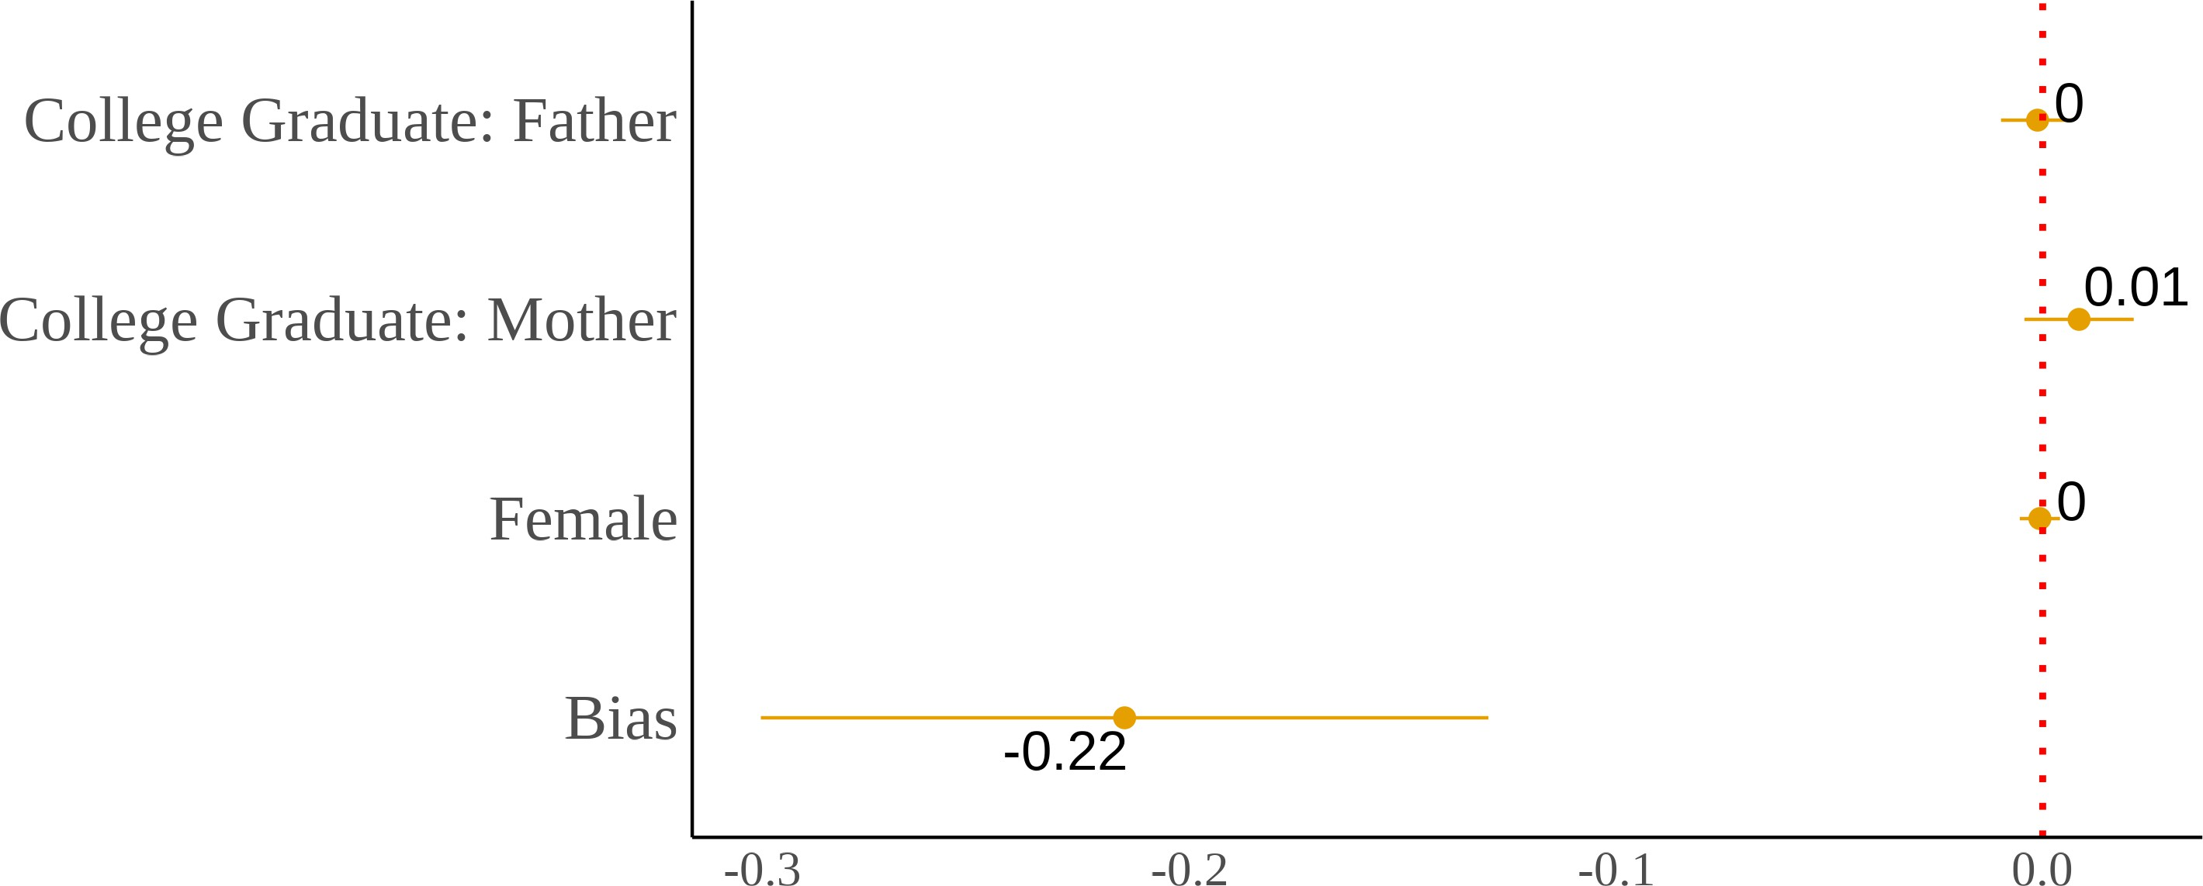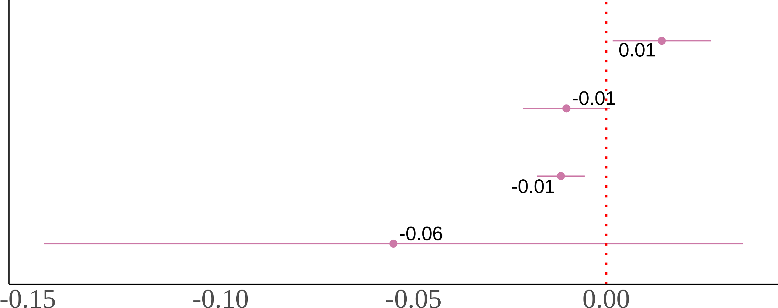

### (c) Second-Generation (d) Third-Generation

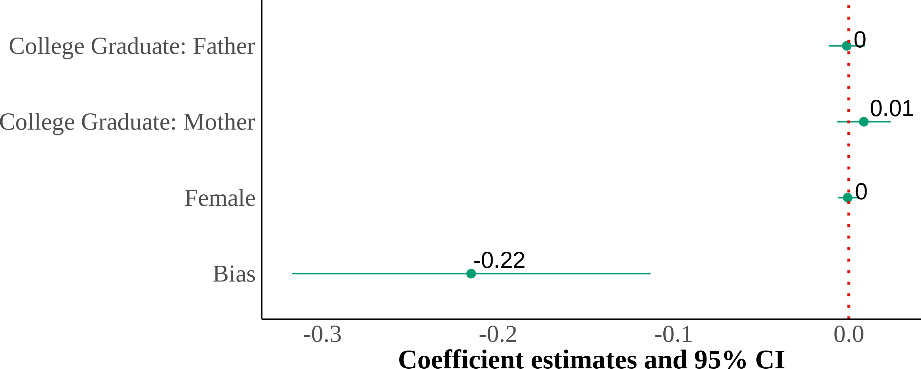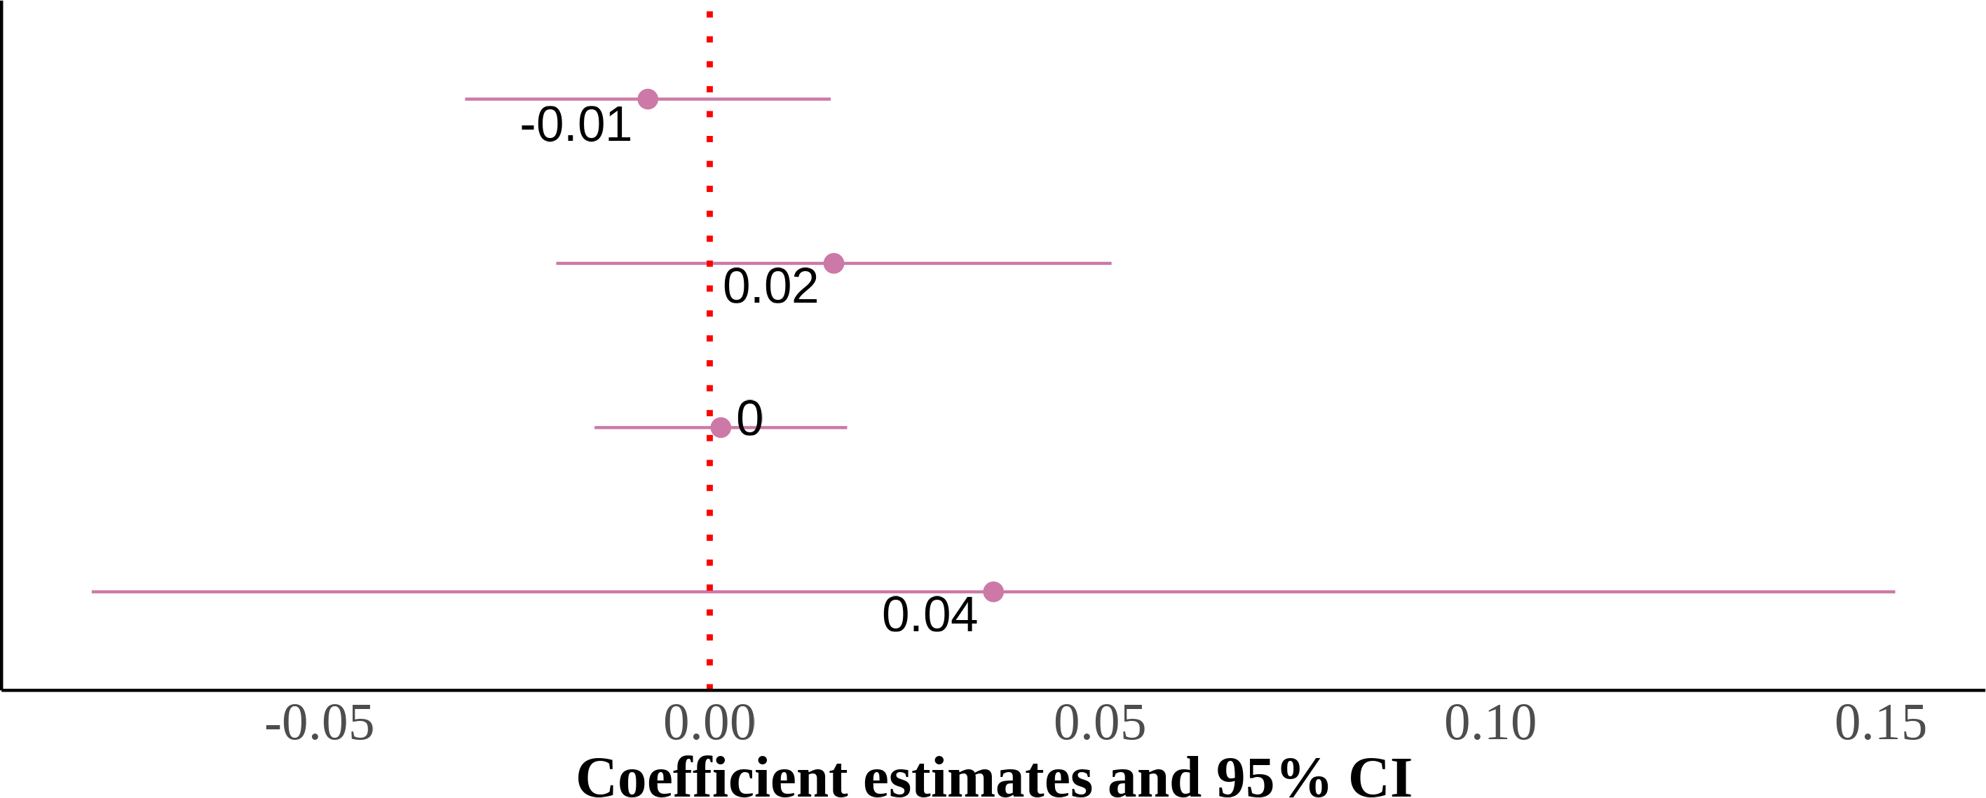

I show four panels of estimating the effect of county-level anti-Asian implicit bias. I include state and year fixed effects with controls for sex, quartic age, and parental education. The dependent variable is self-reported Asian identity and the independent variable is county-level bias. Each panel is the results from the same regression but on different samples that are divided by gener-ation. Standard errors are clustered on the state level. The samples include first-, second-, and third-generation Asian children ages 17 and below who live in intact families. First-generation Asian immigrants are children that were born in a Asian country. Native-born second-generation Asian immigrants are children with at least one parent born in a Asian country. Finally, native-born third-generation Asian immigrants are children with native-born parents and at least one grandparent born in a Asian country.

Figure A.3: Relationship Between Self-Reported Asian Identity and Bias: By Parental Types at the County Level

### (a) Second-Generation (All Parental Types) (b) Asian Fathers-Asian Mothers

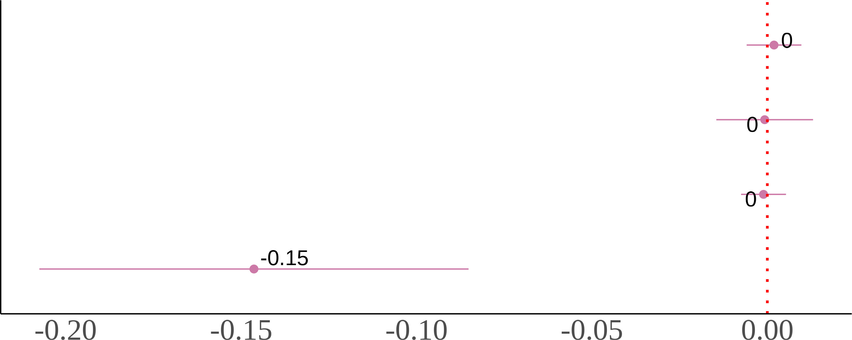

### (c) Asian Fathers-White Mothers (d) White Fathers-Asian Mothers

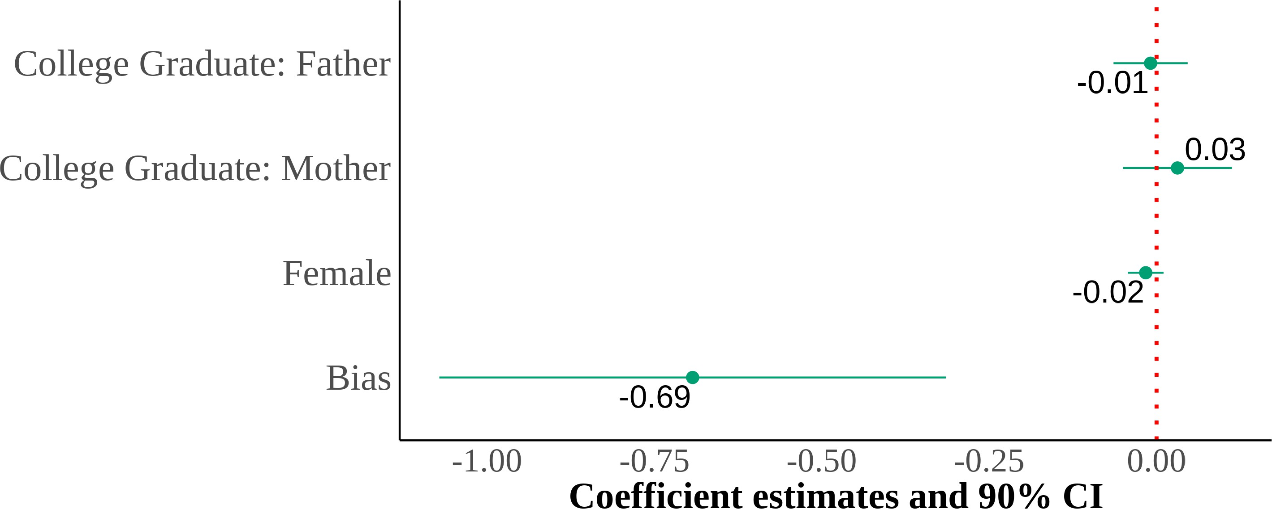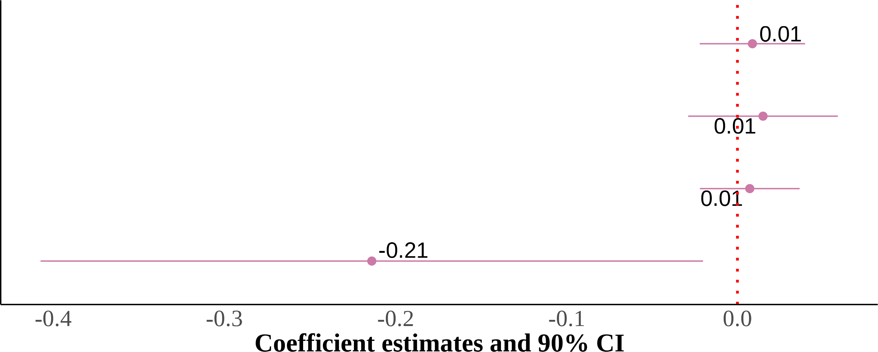

I show four panels of estimating the effect of county-level anti-Asian implicit bias—using the im-plicit association test (IAT) scores. I include state and year fixed effects with controls for sex, quartic age, and parental education. The dependent variable is self-reported Asian identity and the independent variable is county-level bias. Each panel results from the same regression but on different samples divided by parental types. Standard errors are clustered on the state level. The samples include second-generation Asian children ages 17 and below who live in intact fami-lies. Native-born second-generation Asian immigrant children with at least one parent born in an Asian country.

Figure A.4: Relationship Between Self-Reported Asian Identity and Bias: By Gen-eration at the MSA Level

### (a) All Generations (b) First-Generation

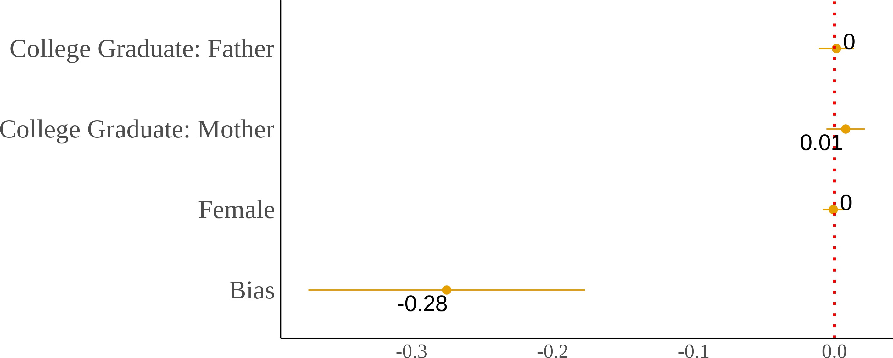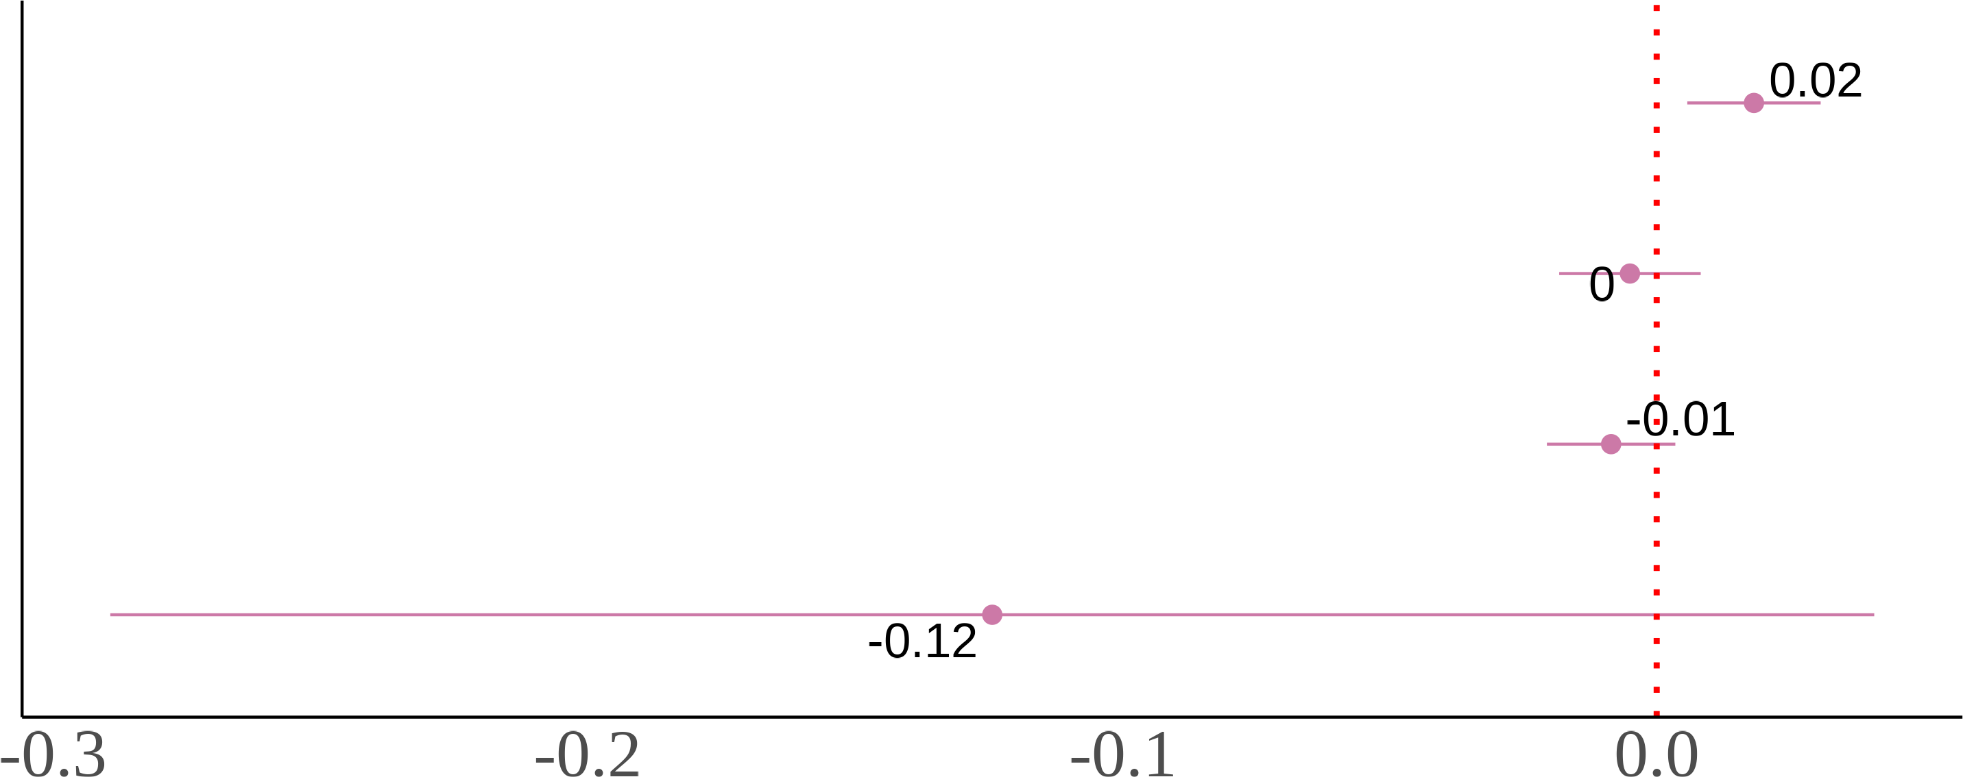

### (c) Second-Generation (d) Third-Generation

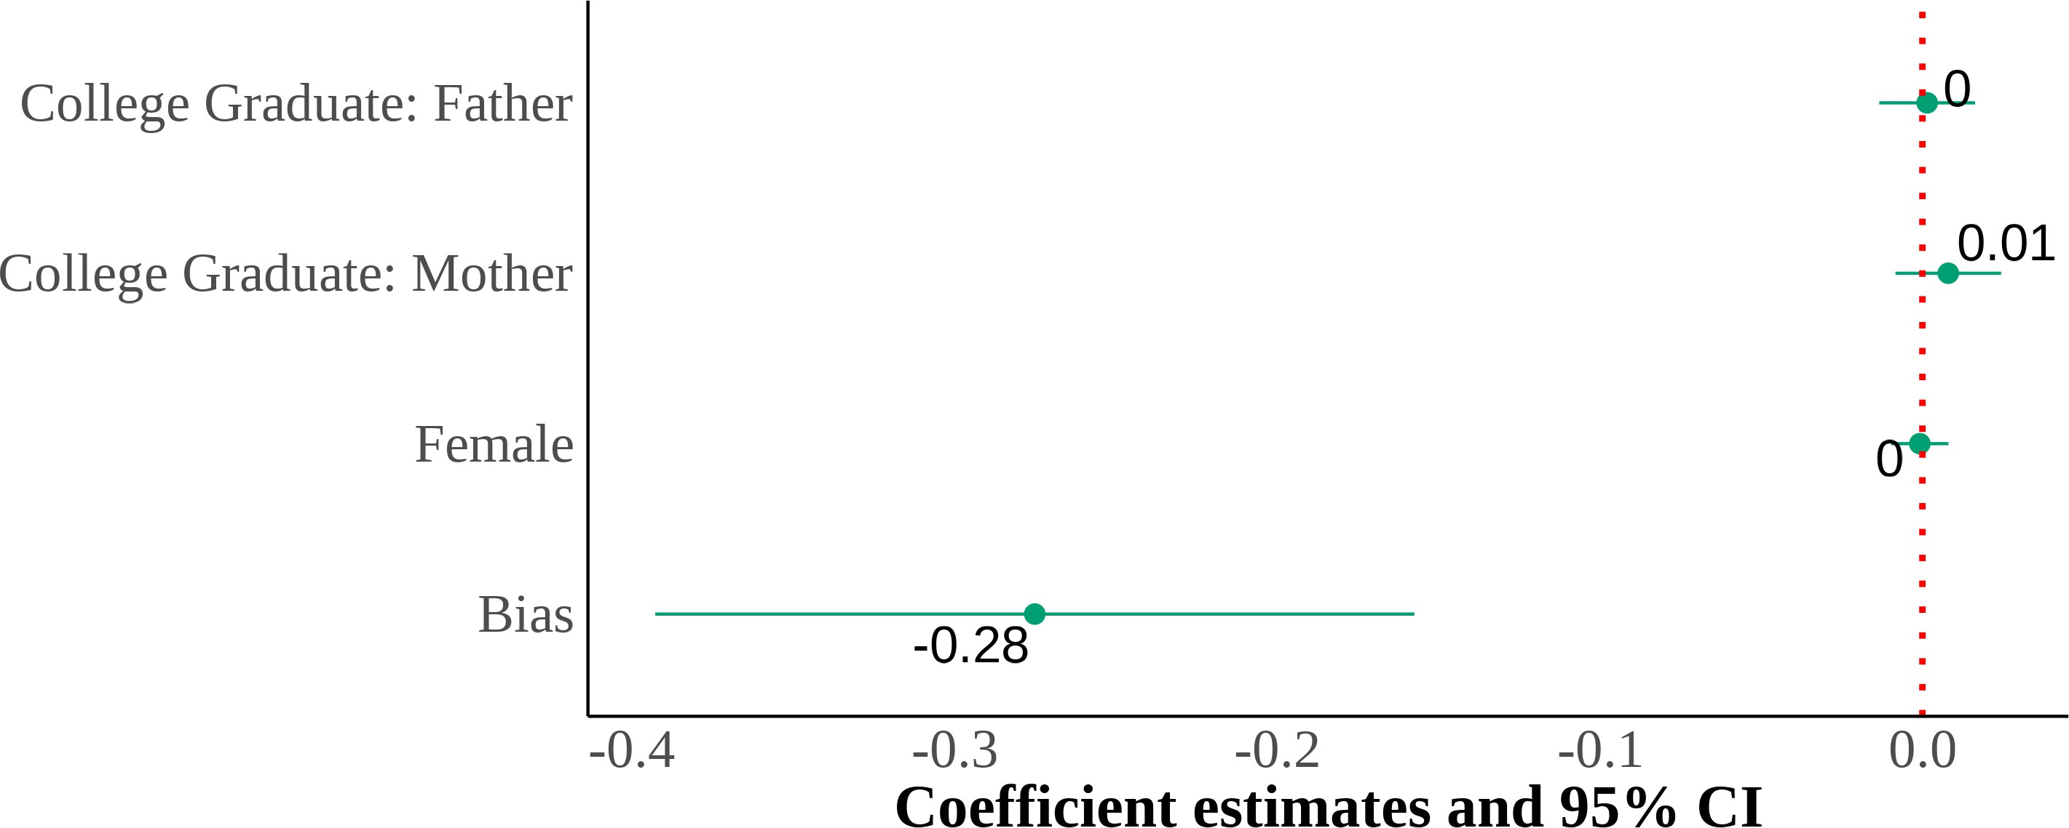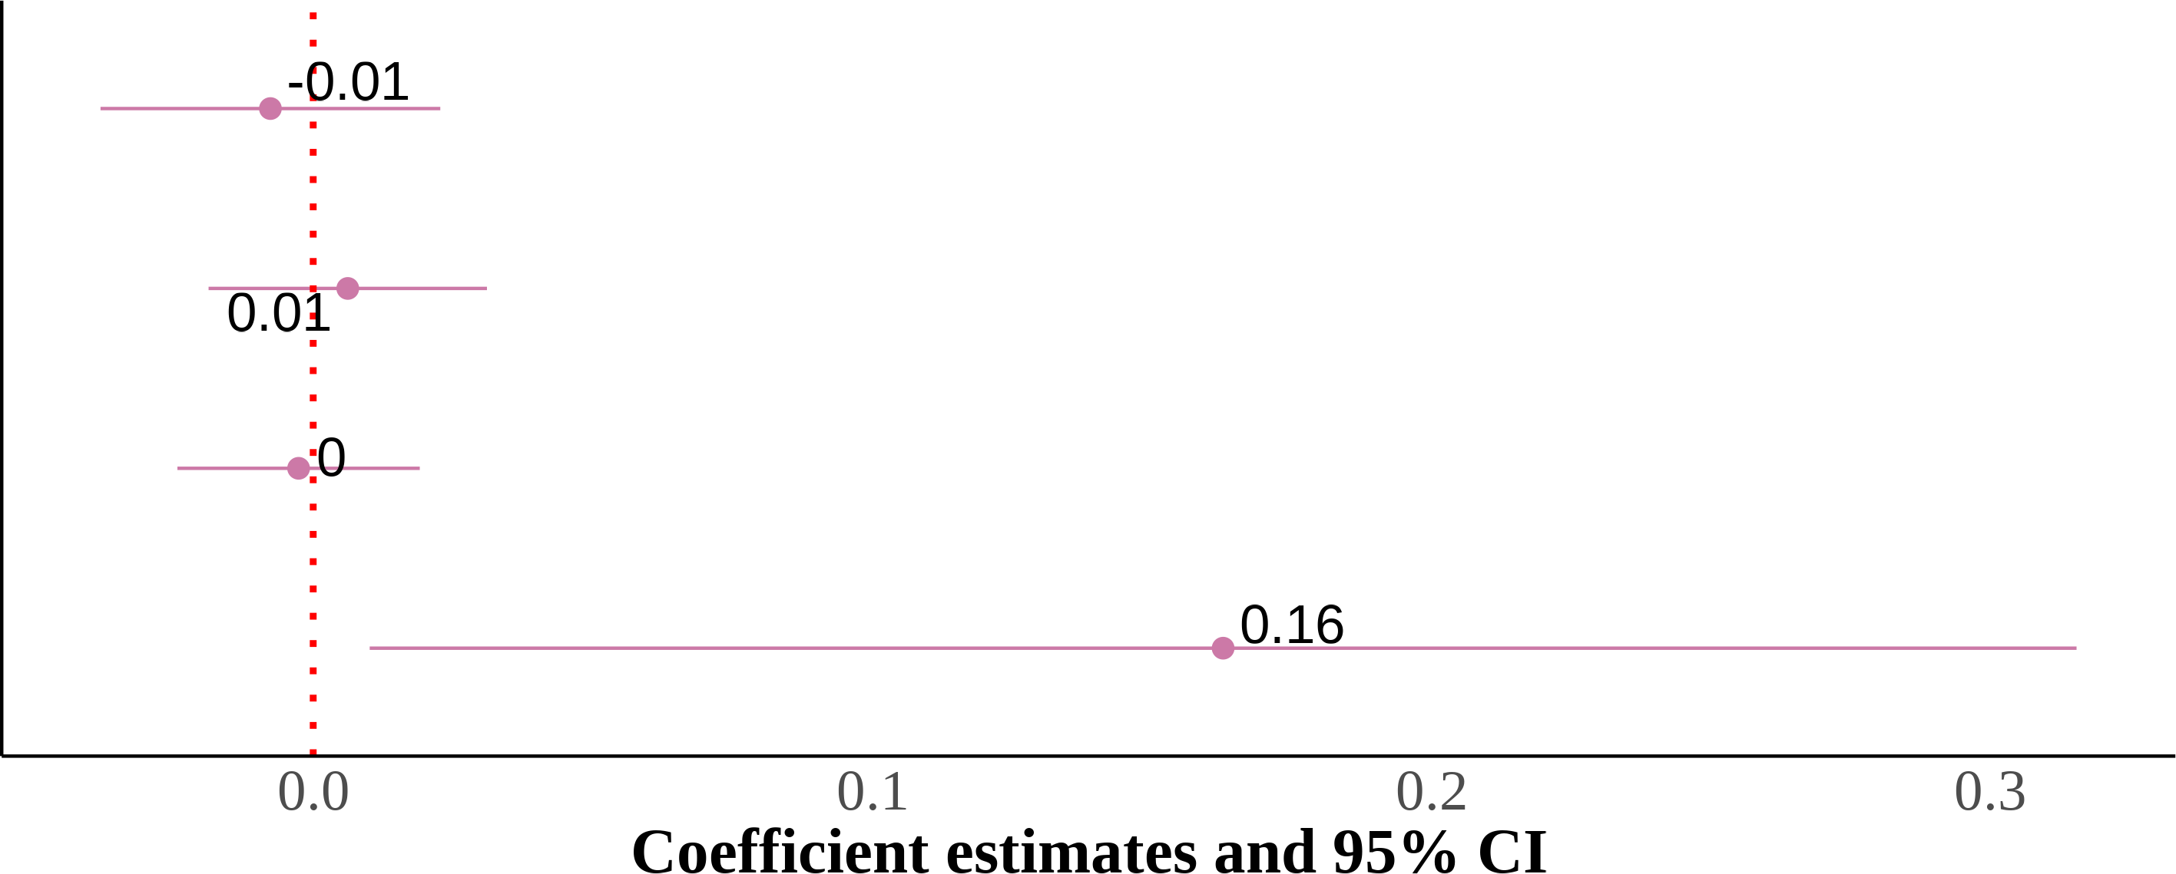

I show four panels of estimating the effect of MSA-level anti-Asian implicit bias. I include state and year fixed effects with controls for sex, quartic age, and parental education. The dependent variable is self-reported Asian identity and the independent variable is MSA-level bias. Each panel is the results from the same regression but on different samples that are divided by generation. Standard errors are clustered on the state level. The samples include first-, second-, and third-generation Asian children ages 17 and below who live in intact families. First-generation Asian immigrants are children that were born in a Asian country. Native-born second-generation Asian immigrants are children with at least one parent born in a Asian country. Finally, native-born third-generation Asian immigrants are children with native-born parents and at least one grandparent born in a Asian country.

Figure A.5: Relationship Between Self-Reported Asian Identity and Bias: By Parental Types at the MSA Level

### (a) Second-Generation (All Parental Types) (b) Asian Fathers-Asian Mothers



### (c) Asian Fathers-White Mothers (d) White Fathers-Asian Mothers



I show four panels of estimating the effect of county-level anti-Asian implicit bias—using the im-plicit association test (IAT) scores. I include state and year fixed effects with controls for sex, quartic age, and parental education. The dependent variable is self-reported Asian identity and the independent variable is county-level bias. Each panel results from the same regression but on different samples divided by parental types. Standard errors are clustered on the state level. The samples include second-generation Asian children ages 17 and below who live in intact fami-lies. Native-born second-generation Asian immigrant children with at least one parent born in an Asian country.

Figure A.6: Interaction Effects of Anti-Asian Bias with Gender and Parental Edu-cation: By Mixed Parental Types Among Adults

### (a) Asian Fathers-White Mothers (b) White Fathers-Asian Mothers

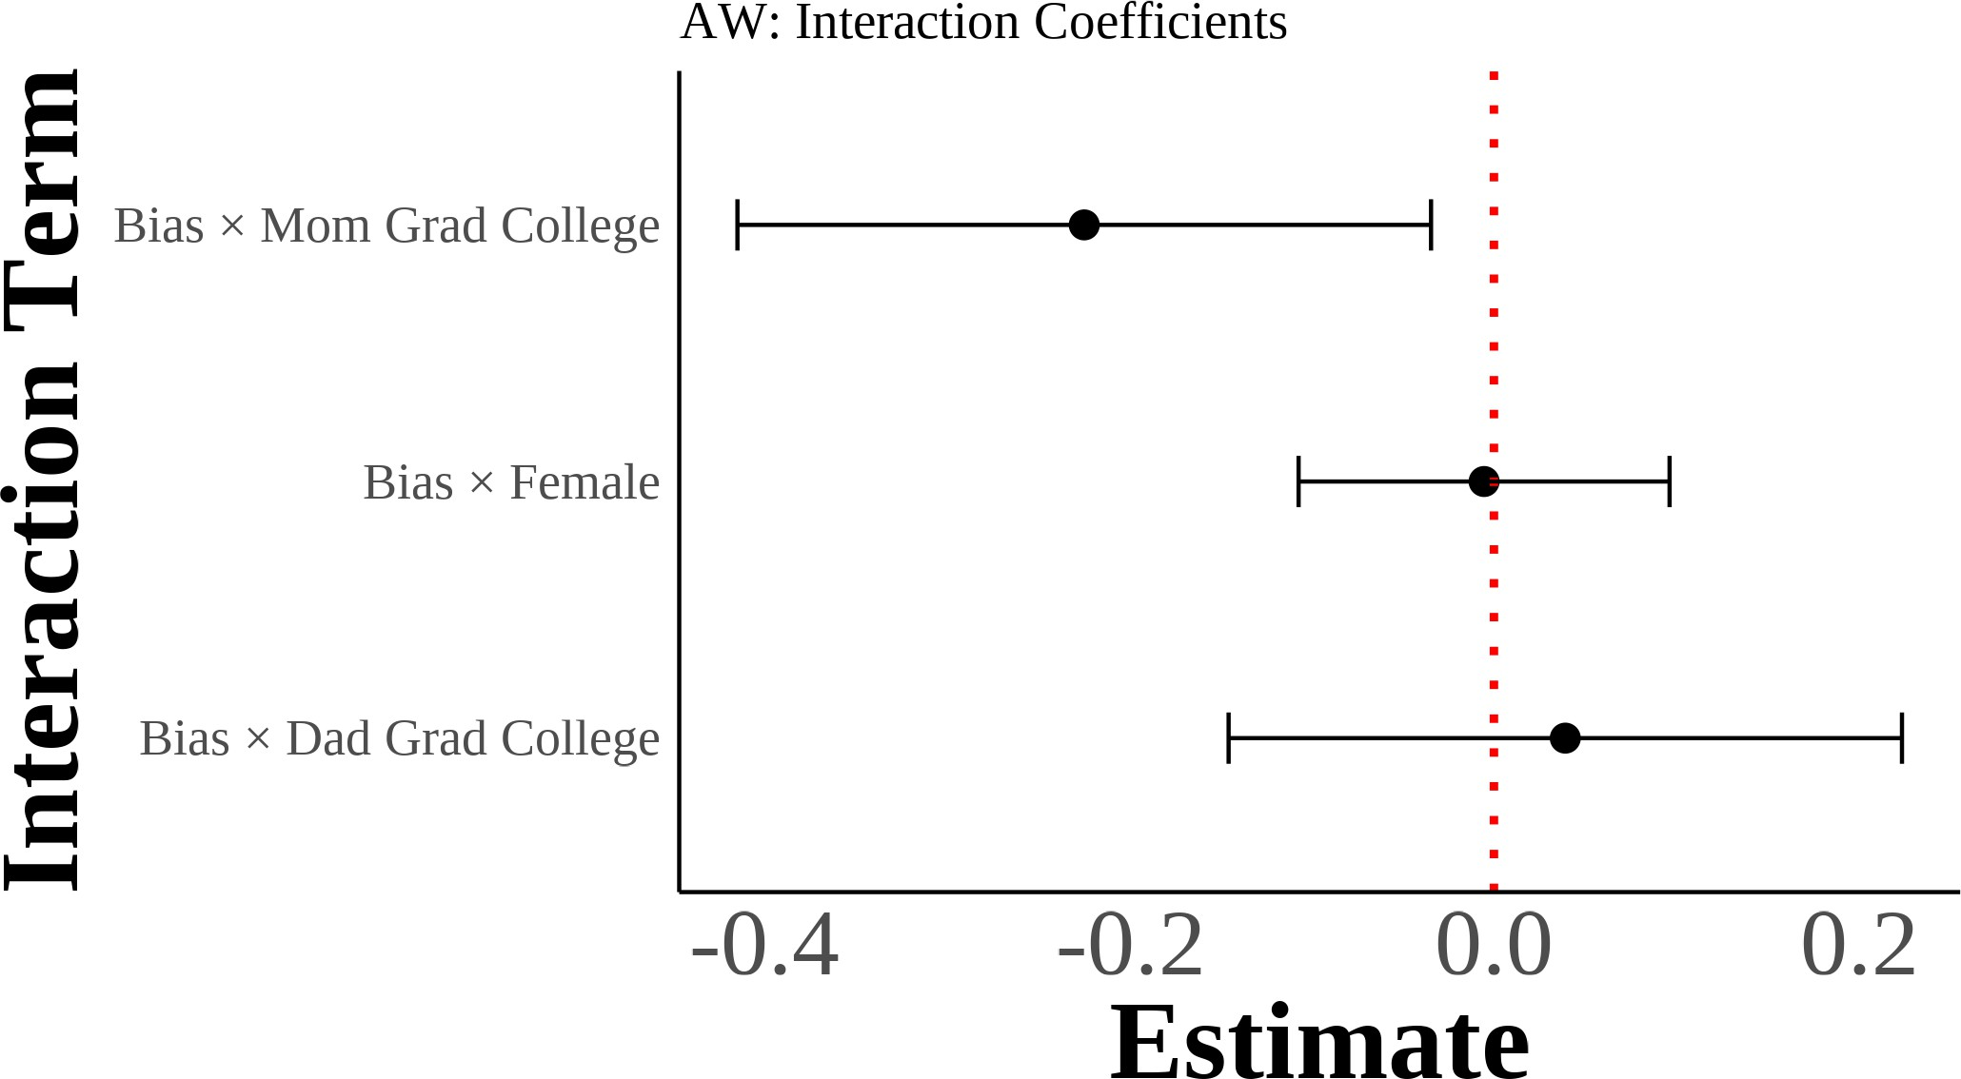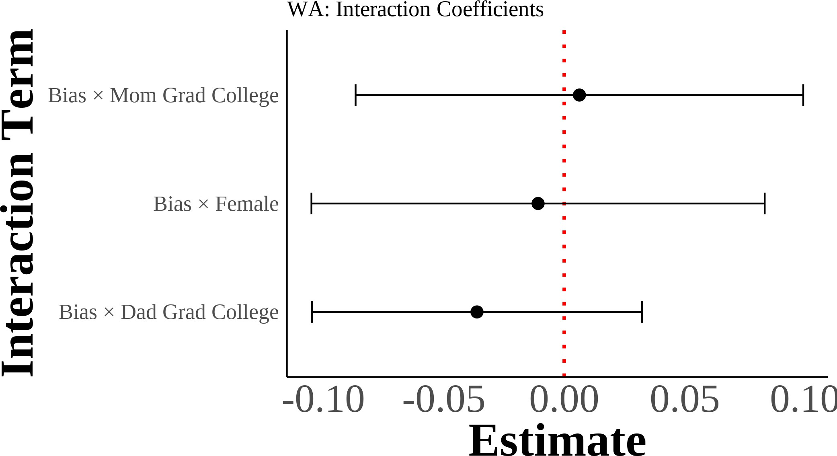

I show interaction coefficients from estimating equation (4) with interaction terms for gender and parental education. I include region *→* year fixed effects with controls for sex, quartic age, years of education, and the inverse hyperbolic sine of income. The dependent variable is self-reported Asian identity and the independent variables include demeaned state-level bias interacted with gender and parental education indicators. Each panel results from separate regressions on dif-ferent samples divided by mixed parental types. Standard errors are clustered on the state level. The samples include second-generation Asian individuals ages 18 and above with mixed-race parentage. Native-born second-generation Asian immigrant individuals with one parent born in an Asian country and one parent born outside of Asia.

Figure A.7: Interaction Effects of Anti-Asian Bias with Gender and Parental Edu-cation: By Asian Grandparent Count Among Third Generation

### (a) One Asian Grandparent (b) Two Asian Grandparents

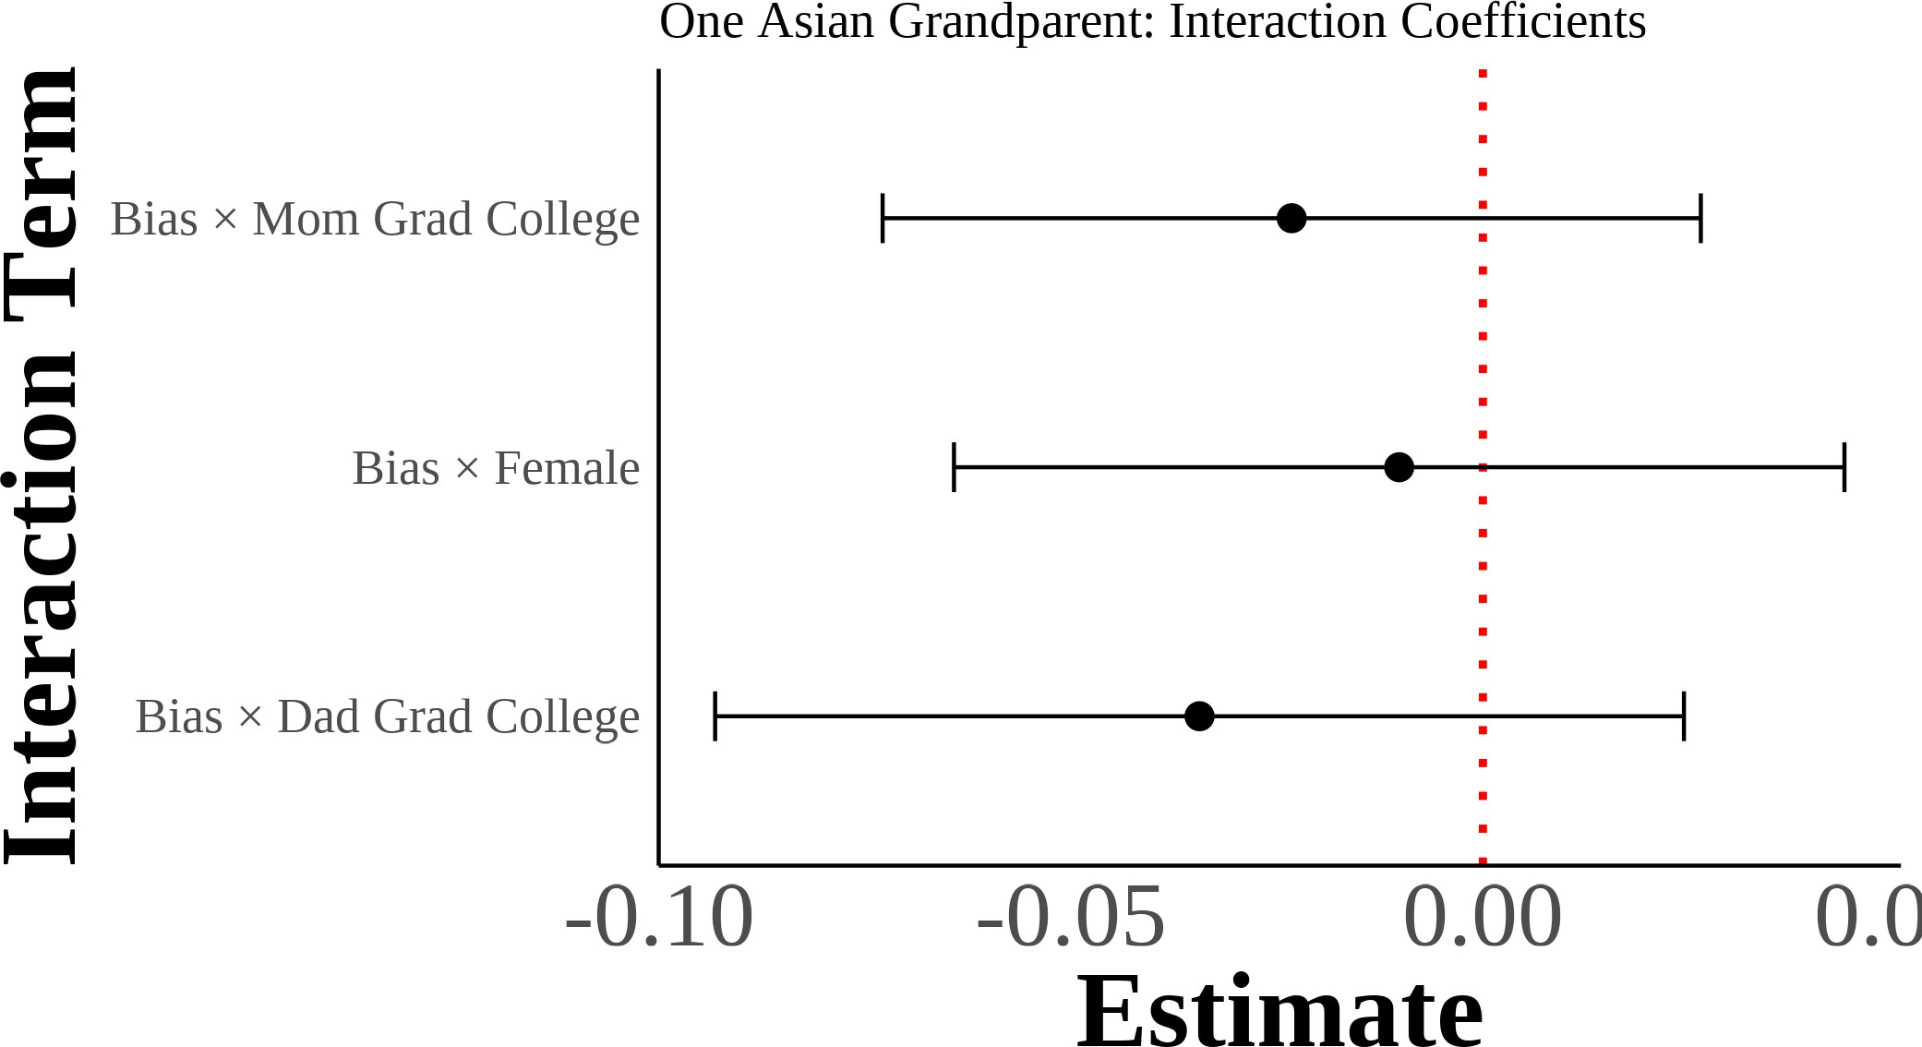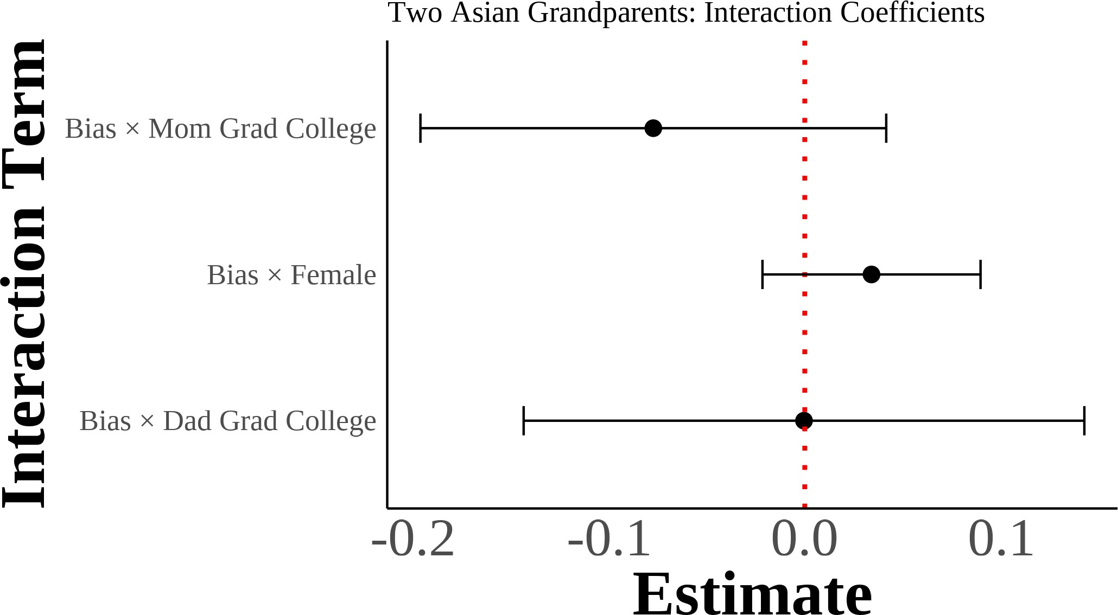

### (c) Three Asian Grandparents

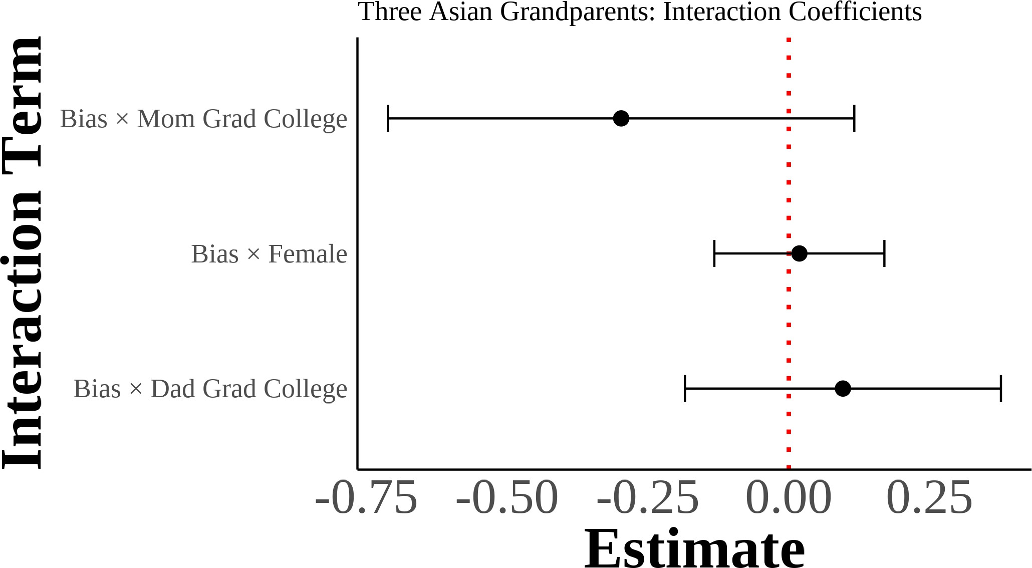

I show interaction coefficients from estimating equation (4) with interaction terms for gender and parental education on third-generation samples. I include region *→* year fixed effects with controls for sex, quartic age, years of education, and the inverse hyperbolic sine of income. The dependent variable is self-reported Asian identity and the independent variables include demeaned state-level bias interacted with gender and parental education indicators. Each panel results from sep-arate regressions on different samples divided by the number of Asian grandparents. Standard errors are clustered on the state level. The samples include third-generation Asian individuals with varying degrees of Asian ancestry through grandparents. Native-born third-generation indi-viduals with at least one grandparent born in an Asian country.

Figure A.8: Multinomial Logit Model: Predicted Probabilities of Racial Identity Choice by Key Covariates (Second-Generation Asian Americans with Asian Fa-thers and White Mothers)

### (a) Anti-Asian Bias (b) Female

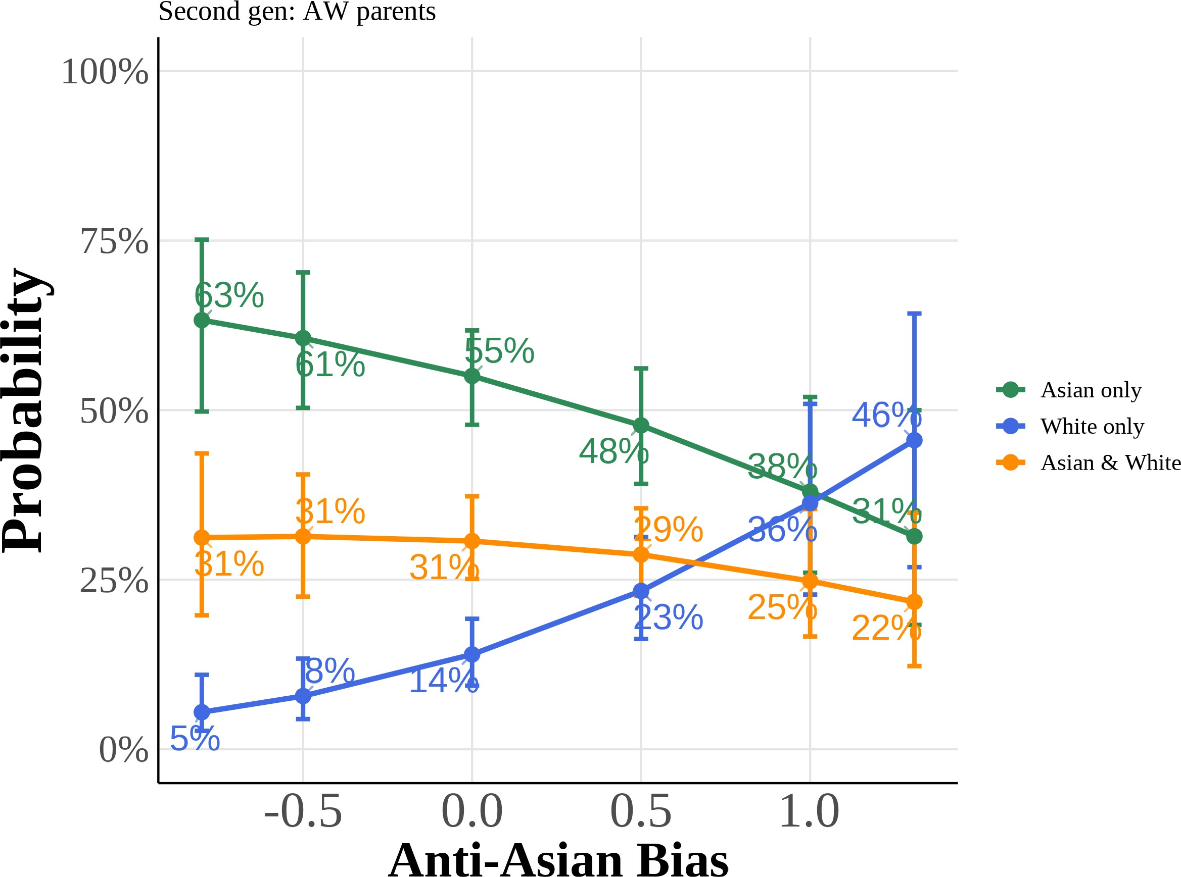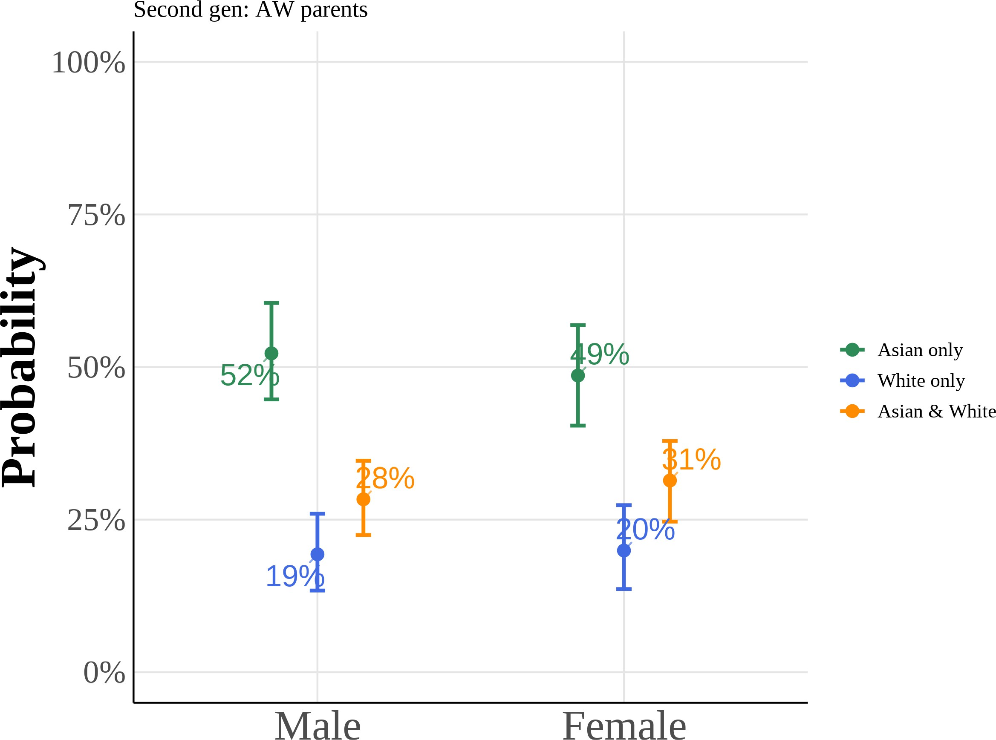

### (c) College Graduate: Mother (d) College Graduate: Father

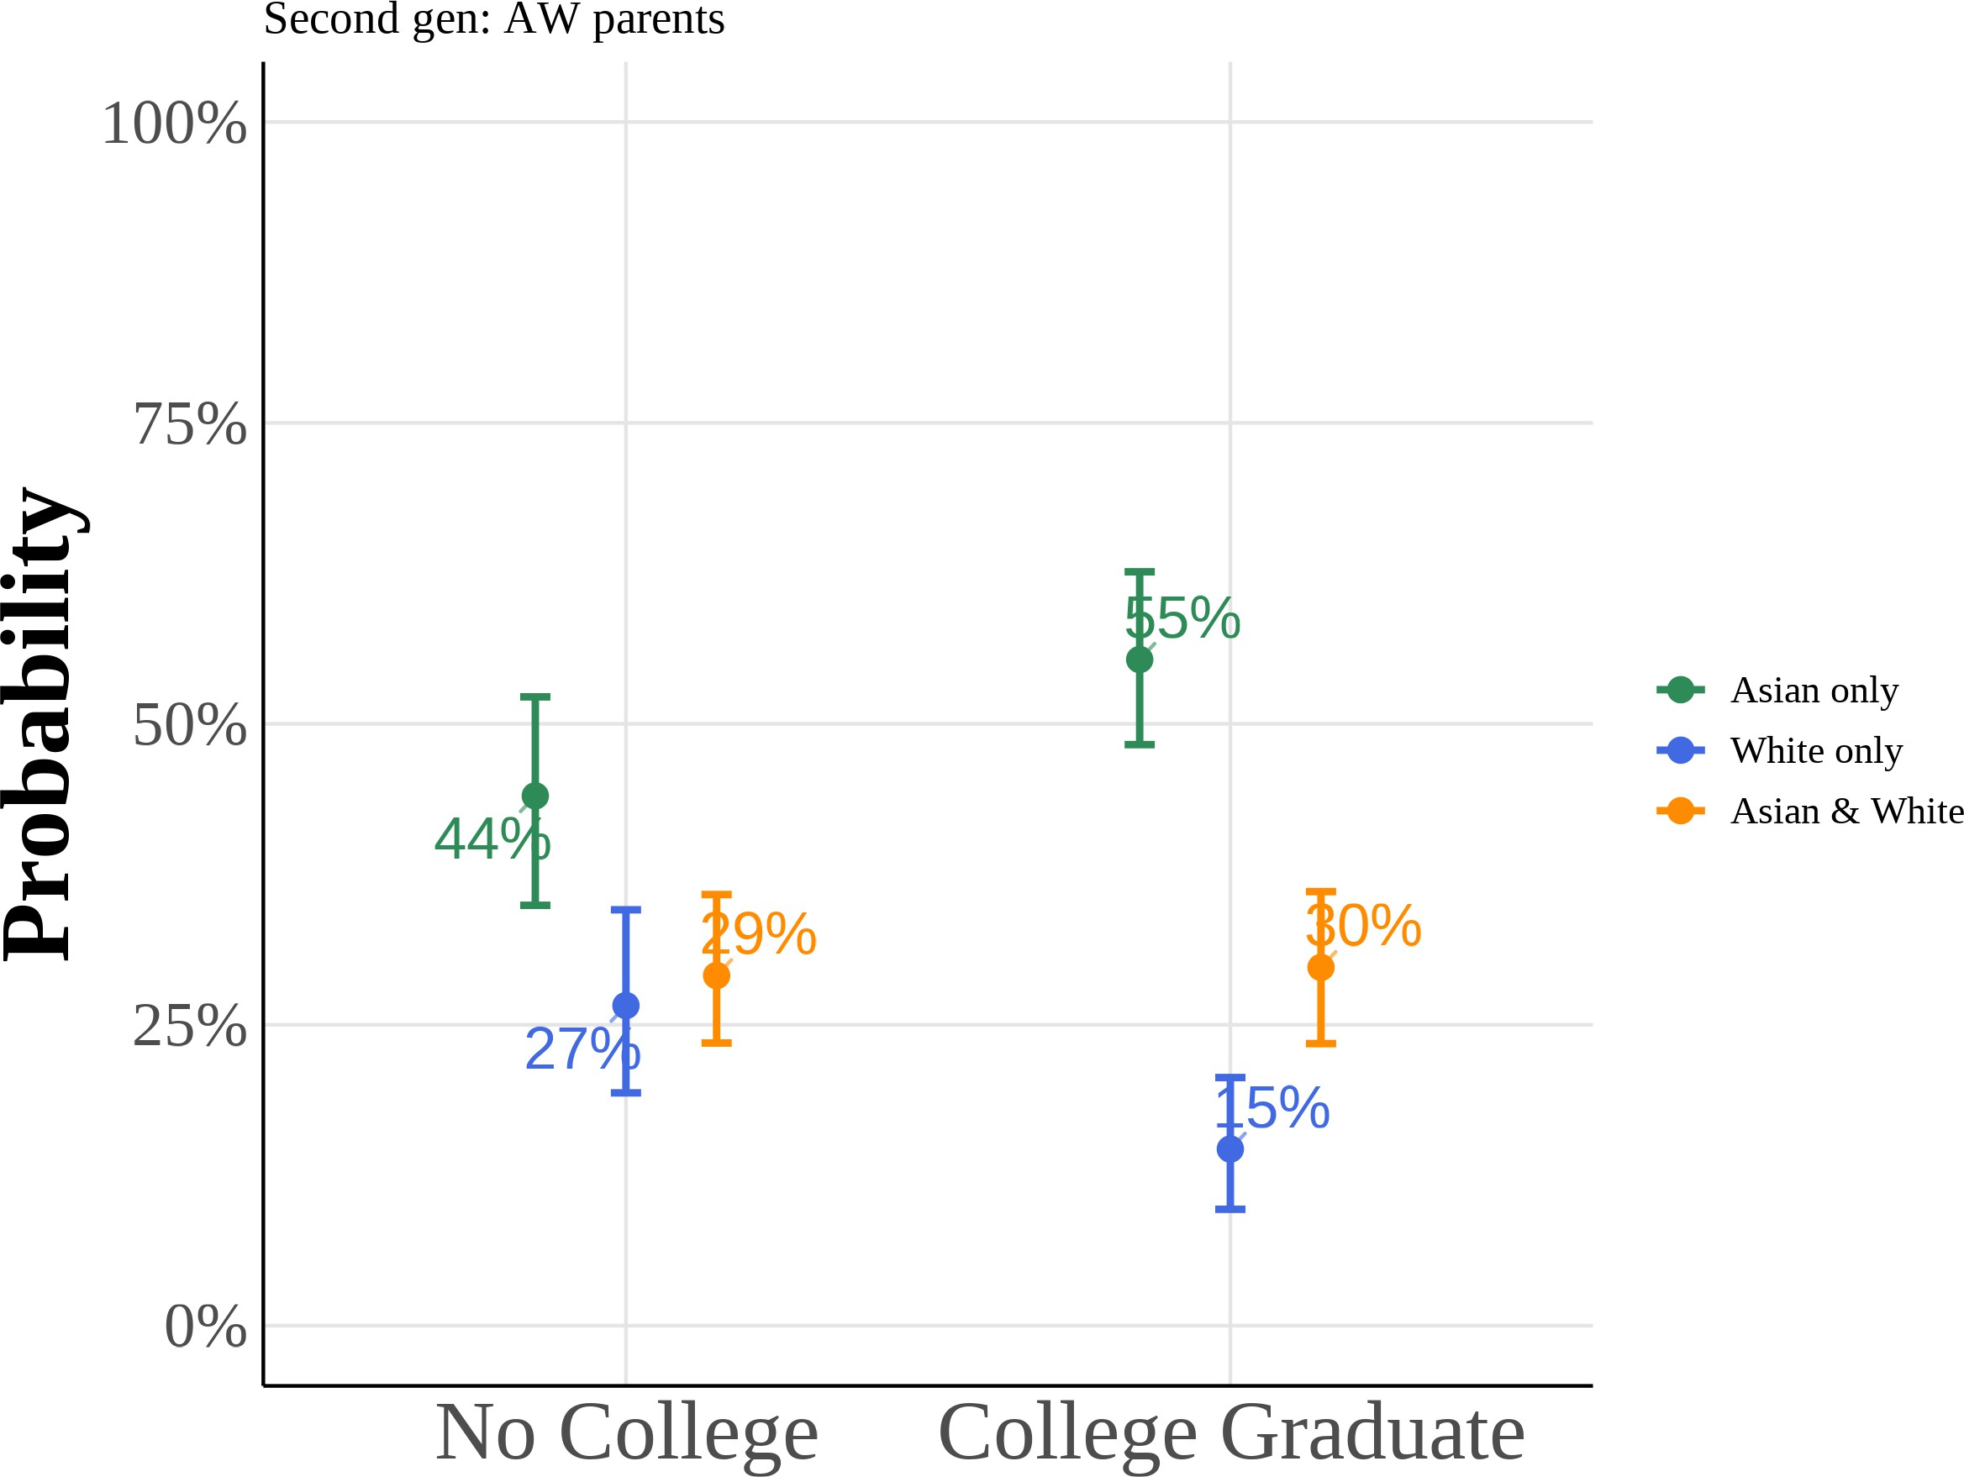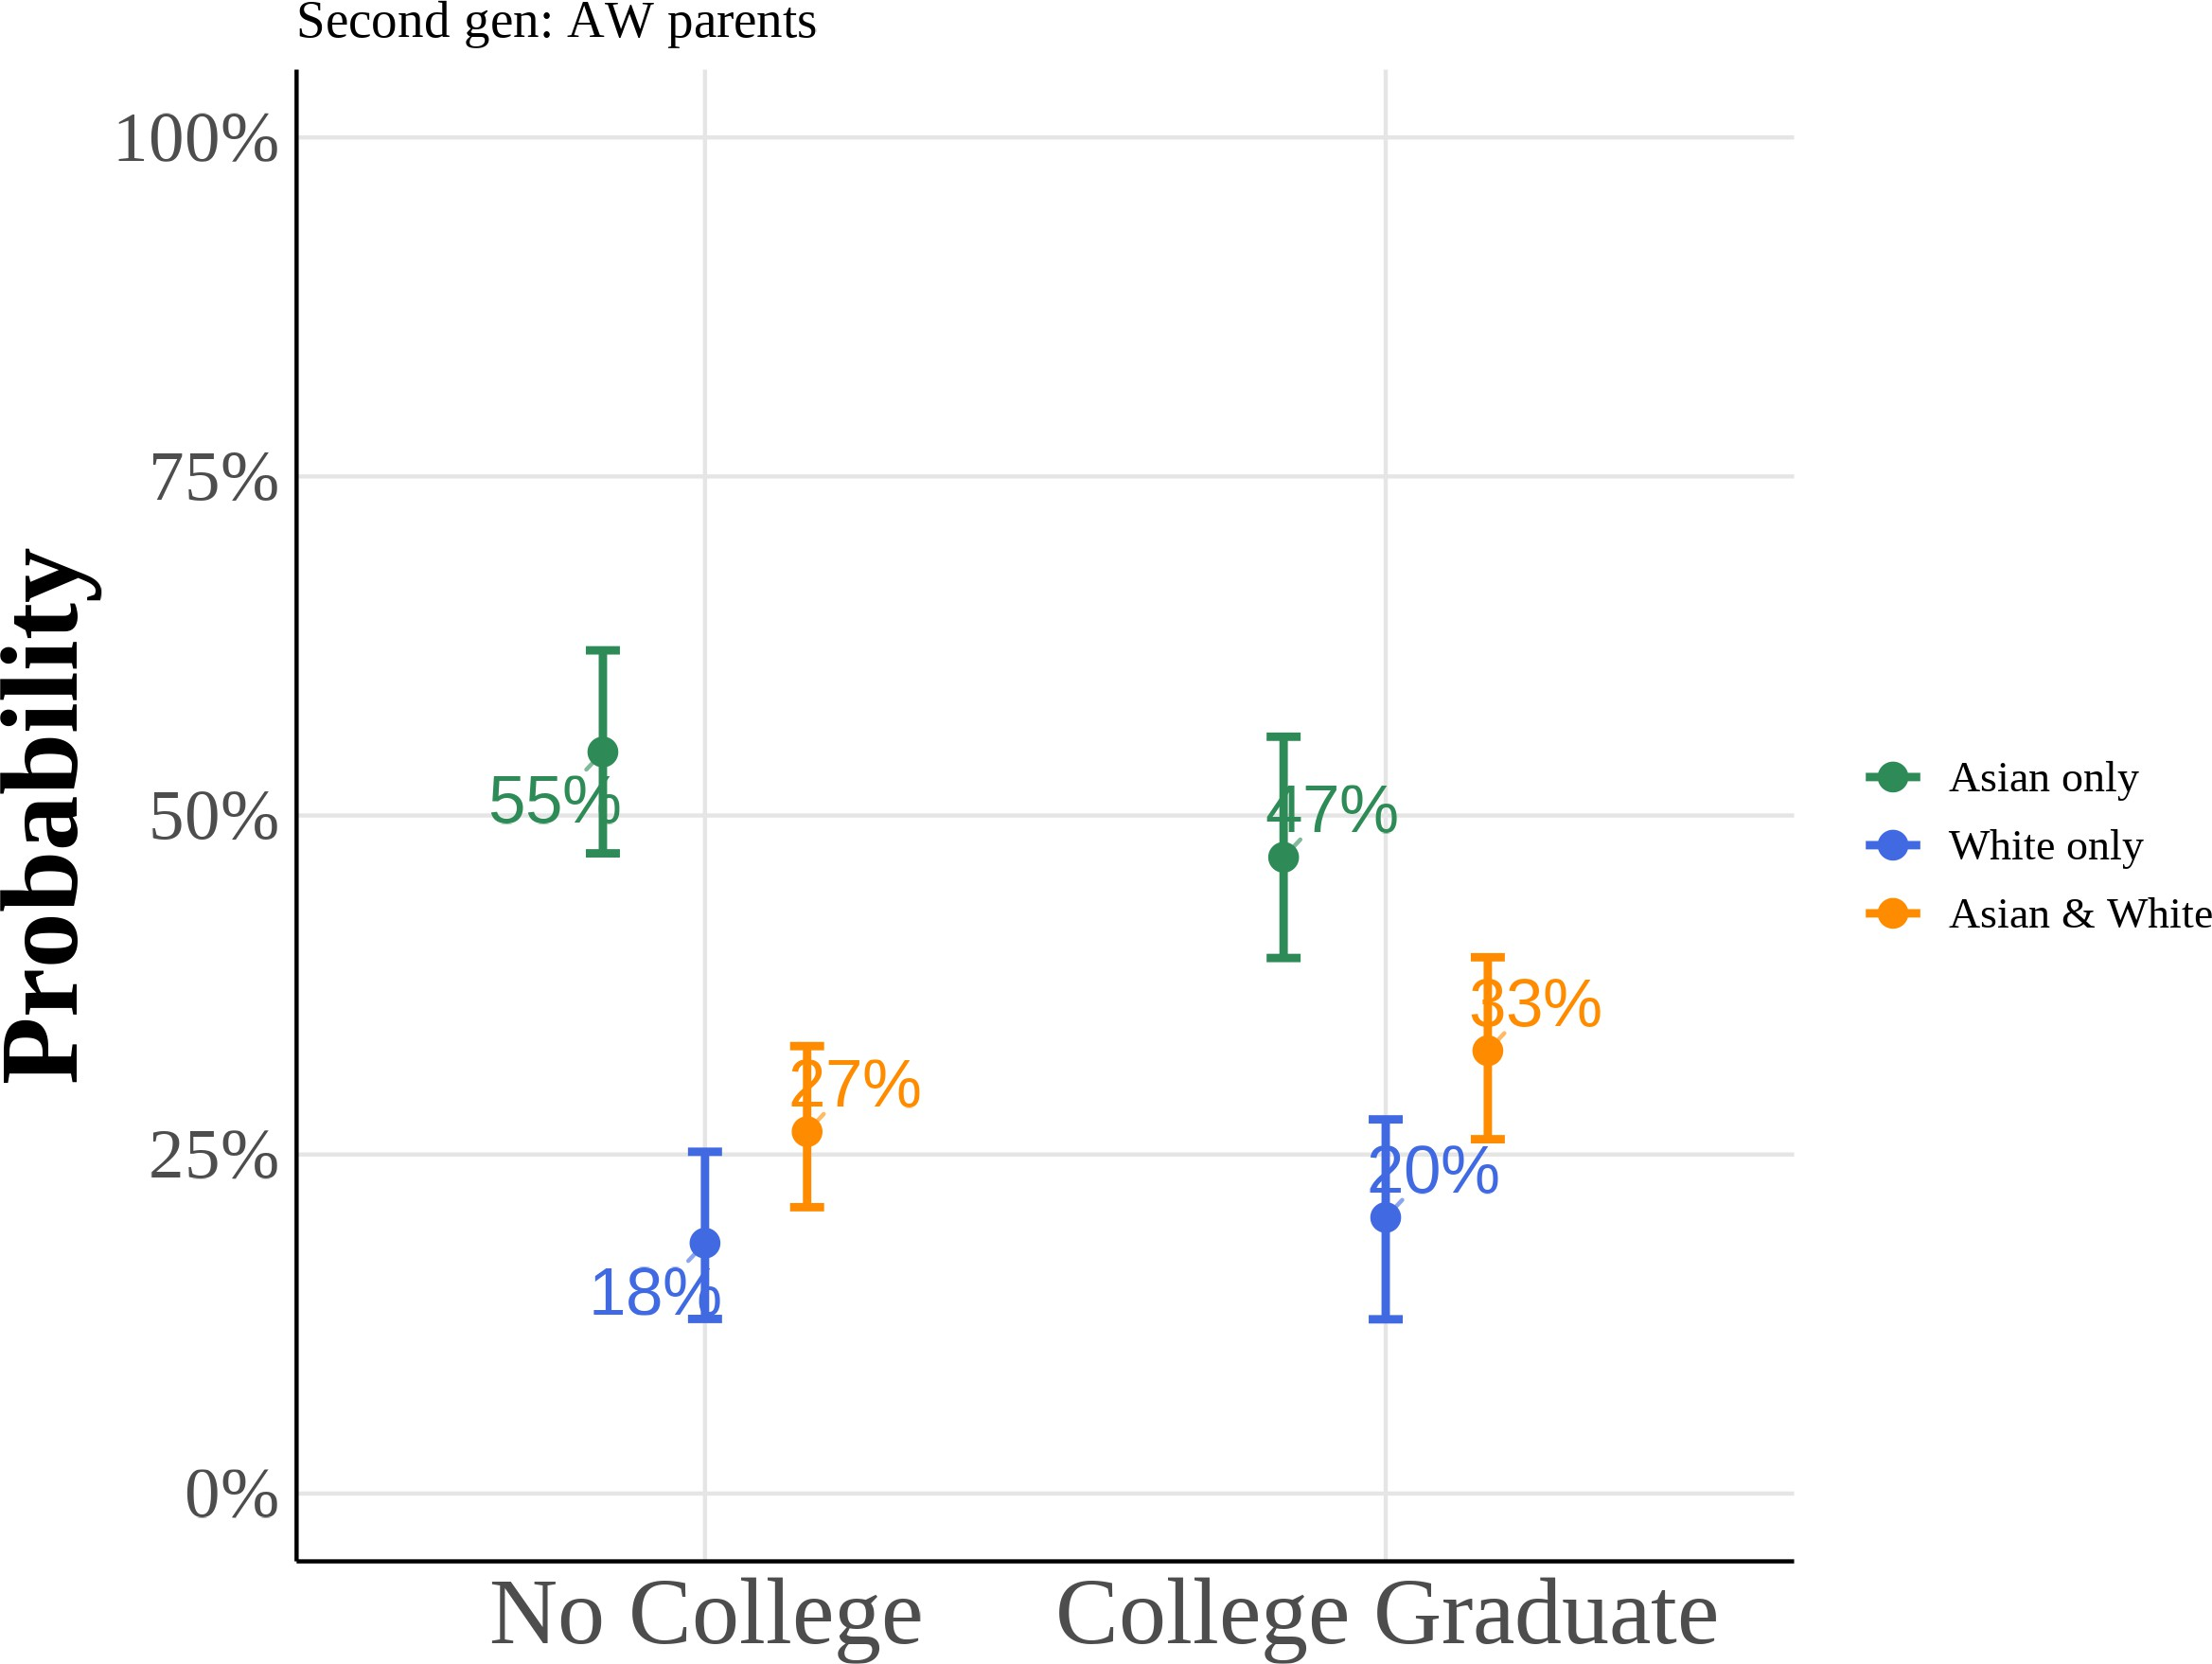

This figure shows predicted probabilities from estimating equation (5) using a multinomial logit model for the subsample of second-generation Asian Americans with Asian fathers and White mothers. The model estimates the probability of choosing “Asian only”, “White only”, or “Asian and White” racial identification as a function of anti-Asian bias, gender, and parental education. I include region *→* year fixed effects with controls for quartic age and local Asian population share. All other variables are held at their sample means. Reported curves depict the median predicted probability across 1,000 bootstrap resamples, and 95% confidence intervals follow the correspond-ing bootstrap percentile limits.

Figure A.9: Multinomial Logit Model: Predicted Probabilities of Racial Identity Choice by Key Covariates (Second-Generation Asian Americans with White Fa-thers and Asian Mothers)

### (a) Anti-Asian Bias (b) Female

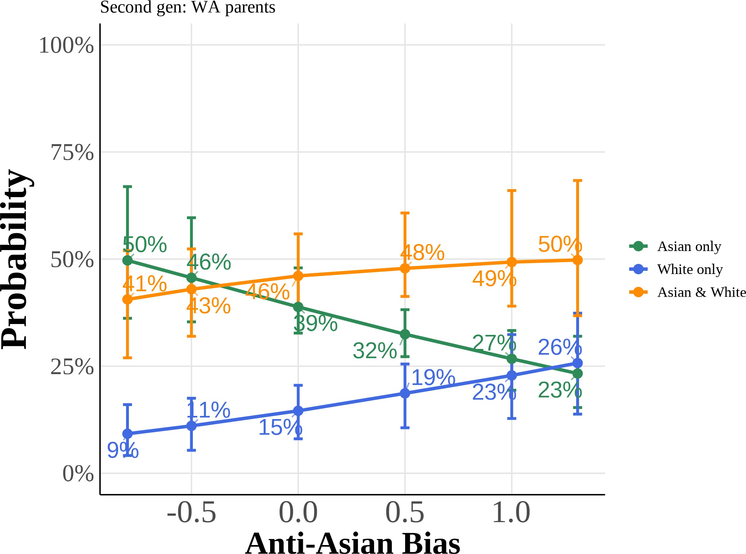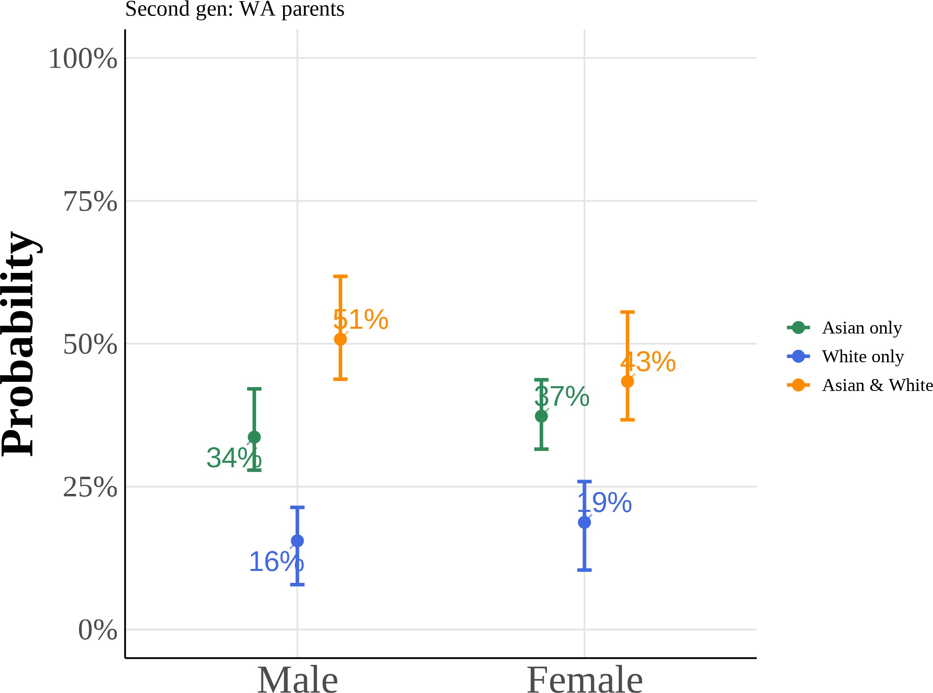

### (c) College Graduate: Mother (d) College Graduate: Father

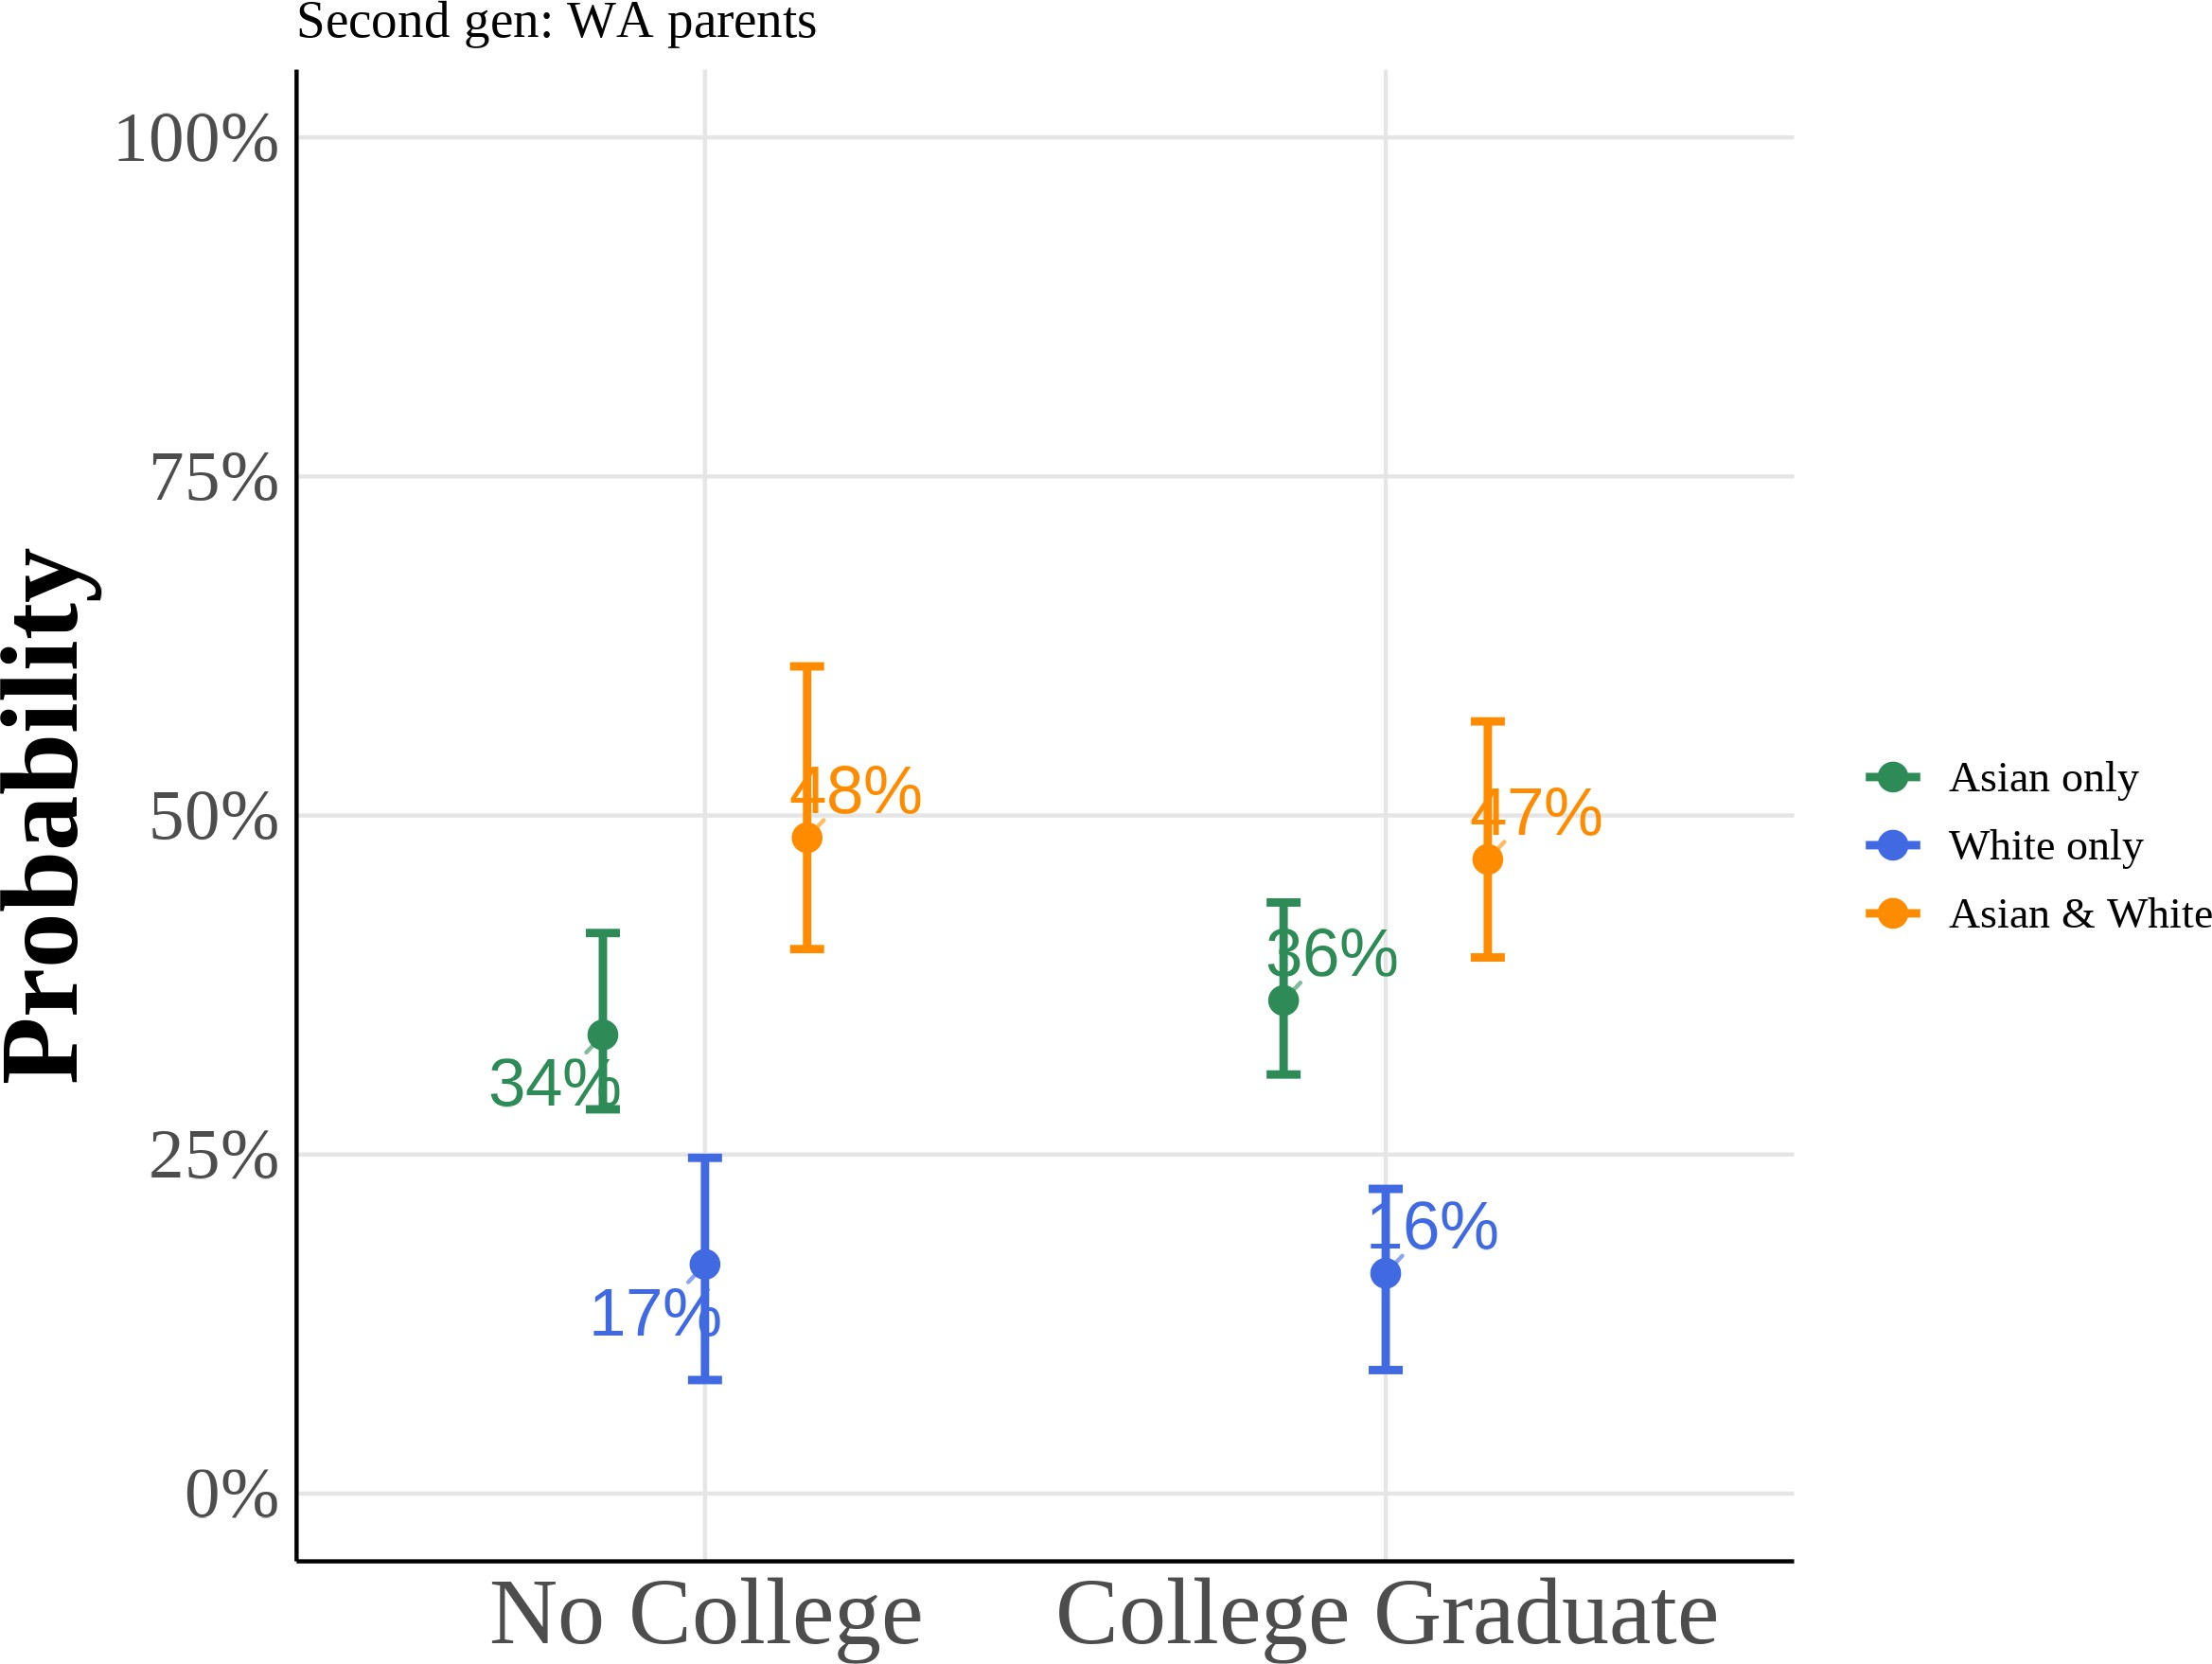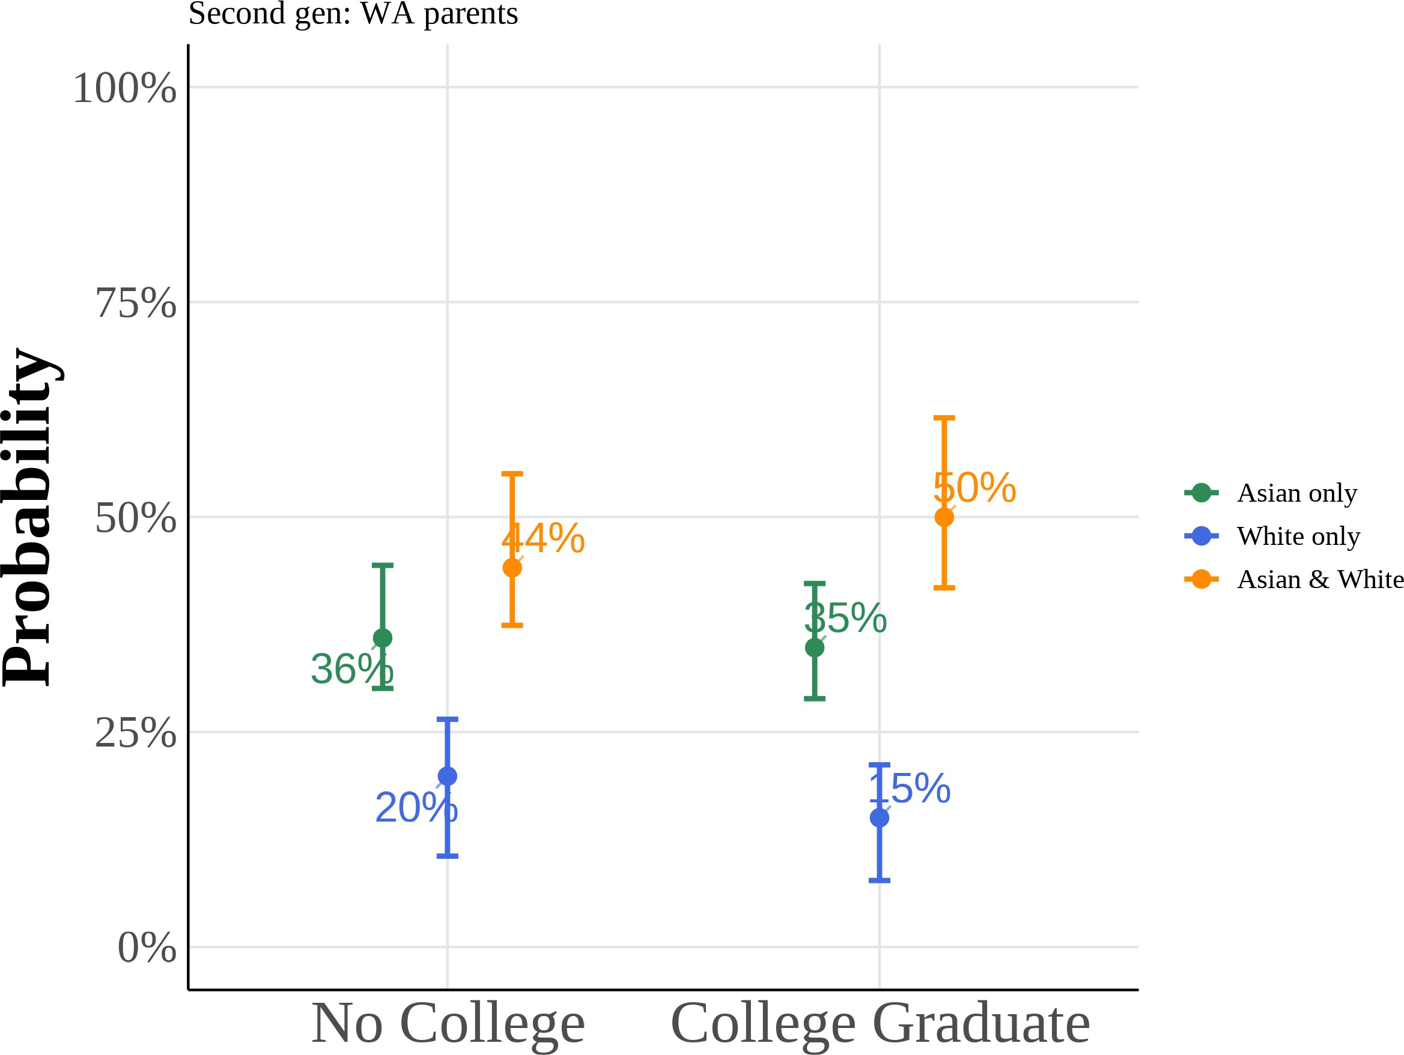

This figure shows predicted probabilities from estimating equation (5) using a multinomial logit model for the subsample of second-generation Asian Americans with White fathers and Asian mothers. The model estimates the probability of choosing “Asian only”, “White only”, or “Asian and White” racial identification as a function of anti-Asian bias, gender, and parental education. I include region *→* year fixed effects with controls for quartic age and local Asian population share. All other variables are held at their sample means. Reported curves depict the median predicted probability across 1,000 bootstrap resamples, and 95% confidence intervals follow the correspond-ing bootstrap percentile limits.

Figure A.10: Multinomial Logit Model: Predicted Probabilities of Racial Identity Choice by Anti-Asian Bias and Gender (Second Generation Adults, AW/WA)

### (a) Anti-Asian Bias (AW) (b) Anti-Asian Bias (WA)

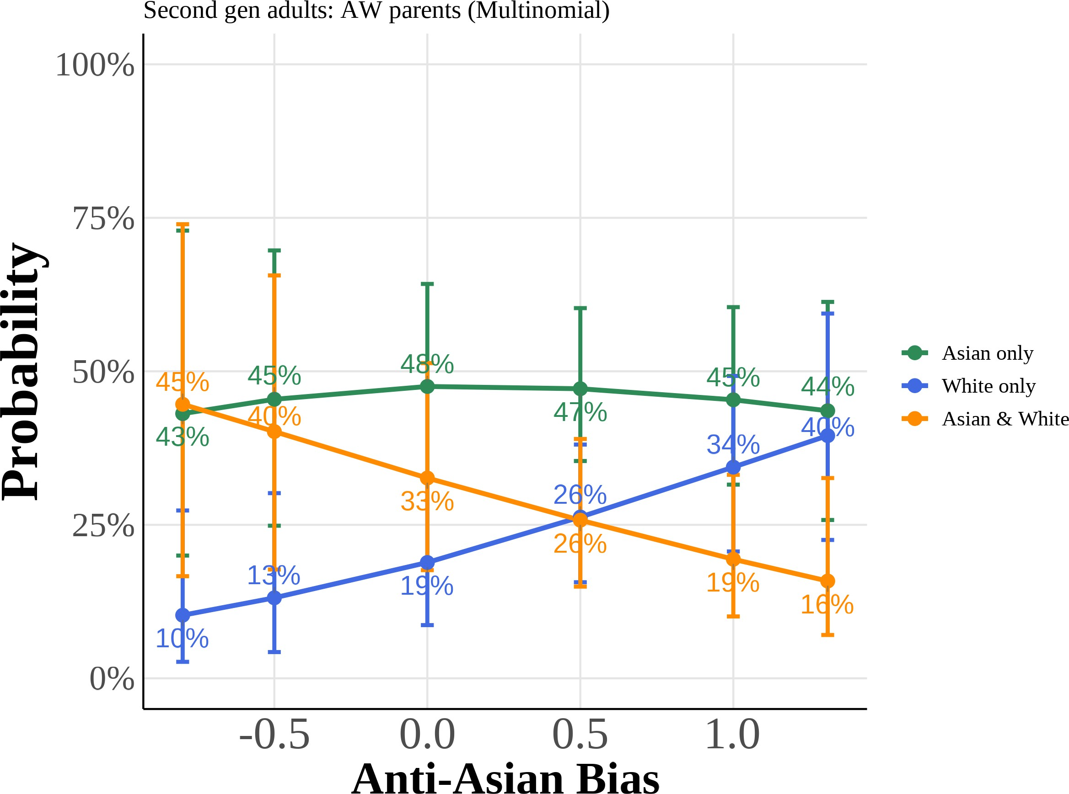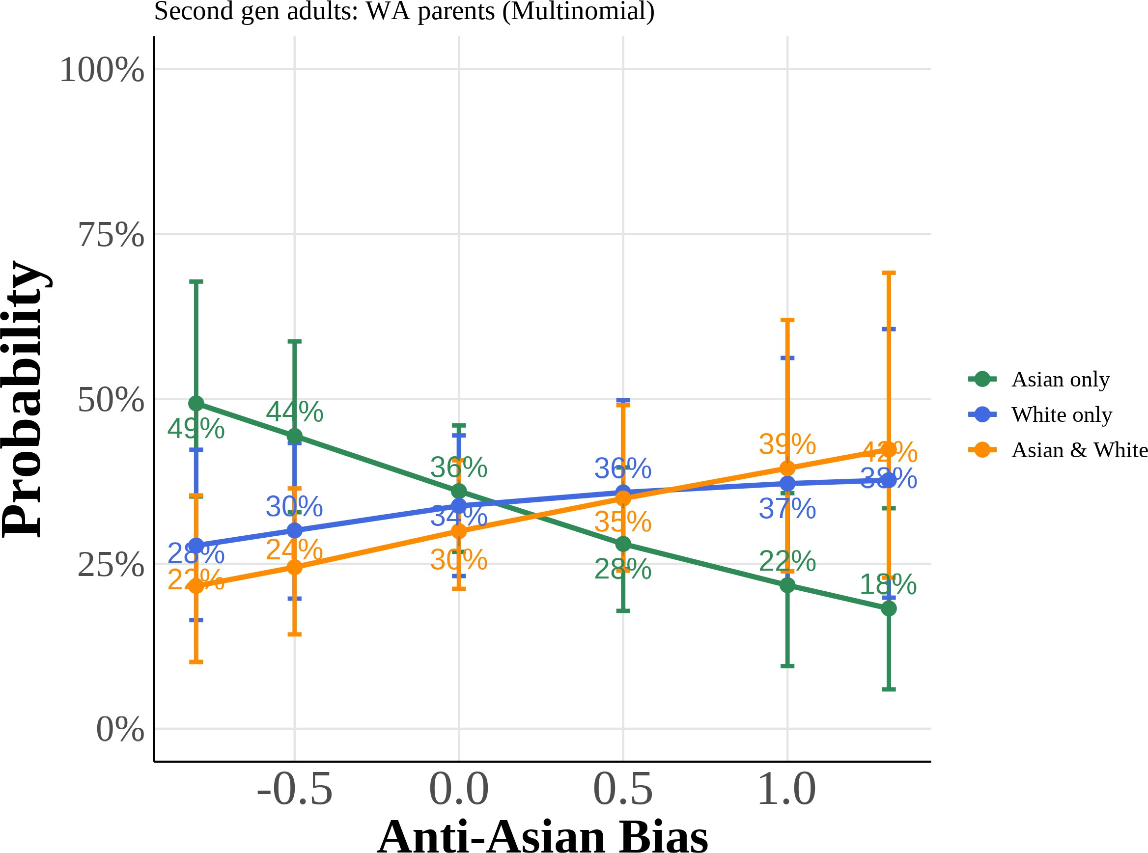

### (c) Female (AW) (d) Female (WA)

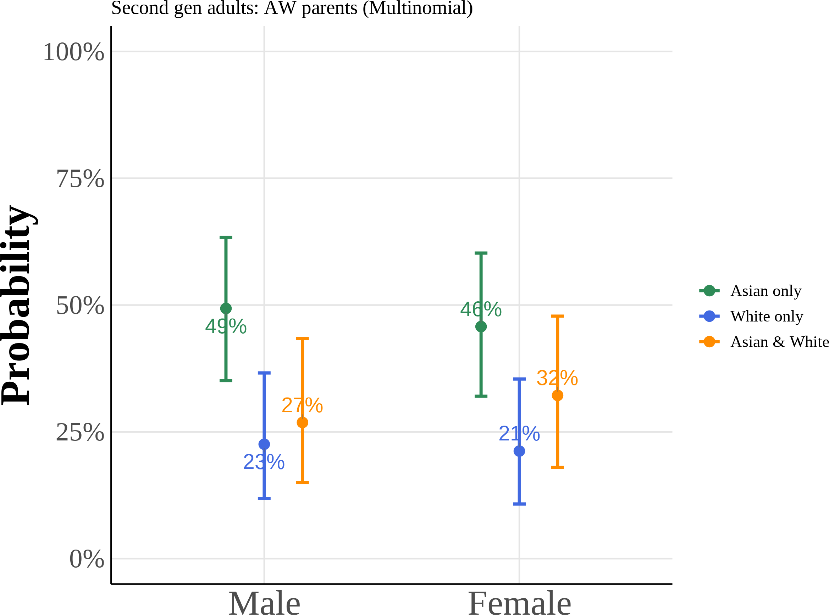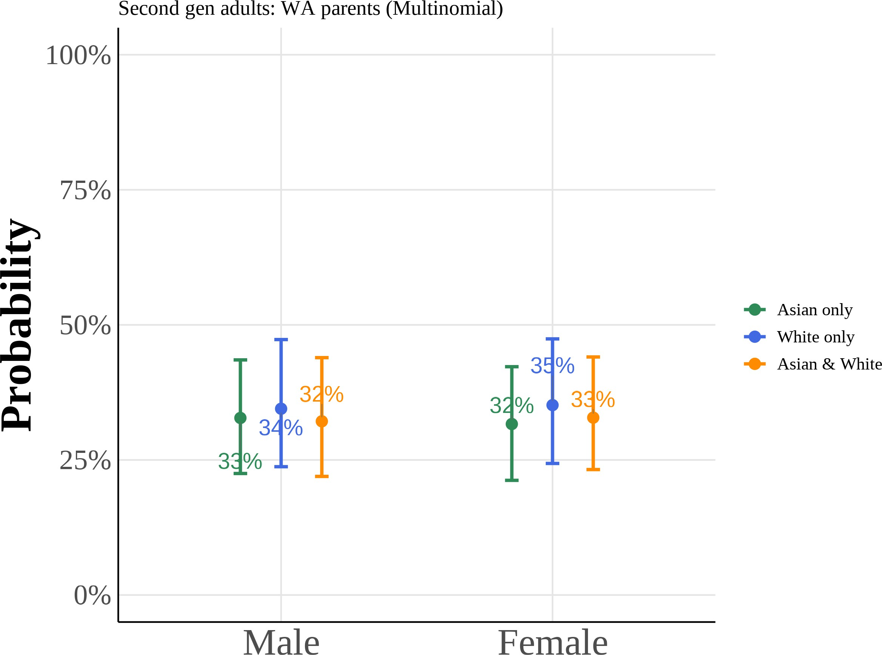

Predicted probabilities from multinomial logit models for second-generation adults with Asian fa-ther/White mother (AW) and White father/Asian mother (WA). Each panel shows the probability of choosing each racial identity as a function of anti-Asian bias or gender, holding other covariates at their means. Curves plot the median predicted probability across 1,000 bootstrap resamples, with 95% confidence intervals given by the bootstrap percentile bounds.

Figure A.11: Multinomial Logit Model: Predicted Probabilities of Racial Identity Choice by Years of Education and Income (Second Generation Adults, AW/WA)

### (a) Years of Education (AW) (b) Years of Education (WA)

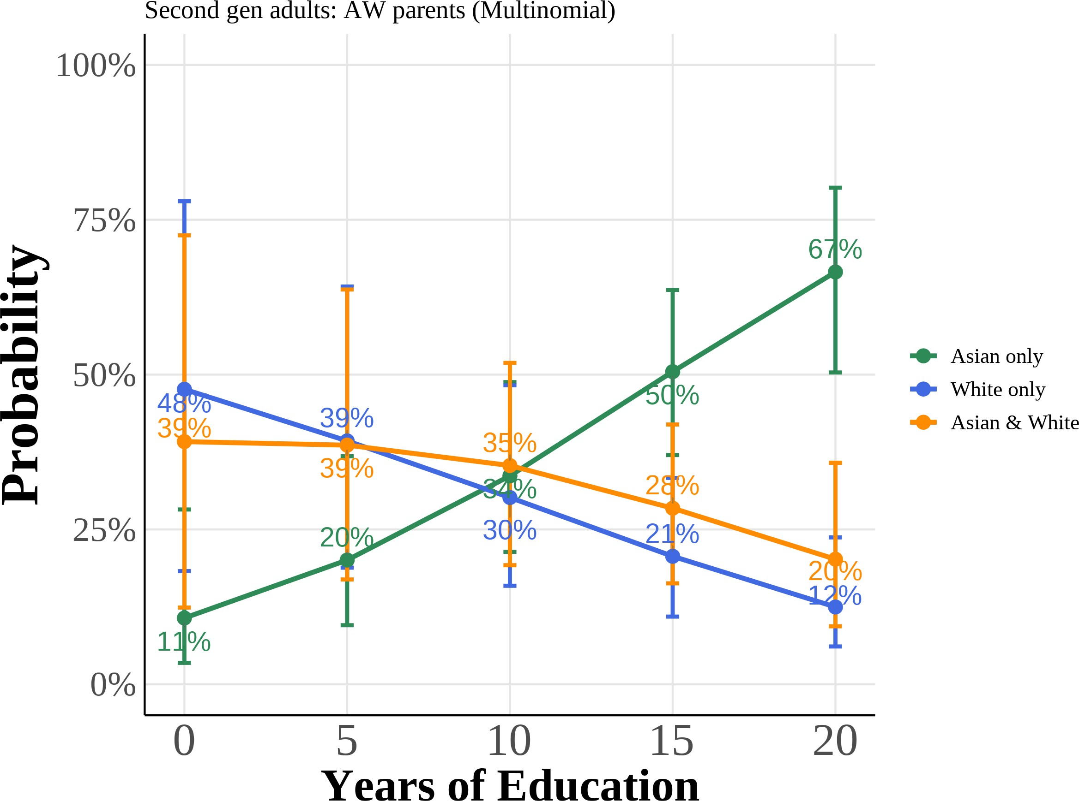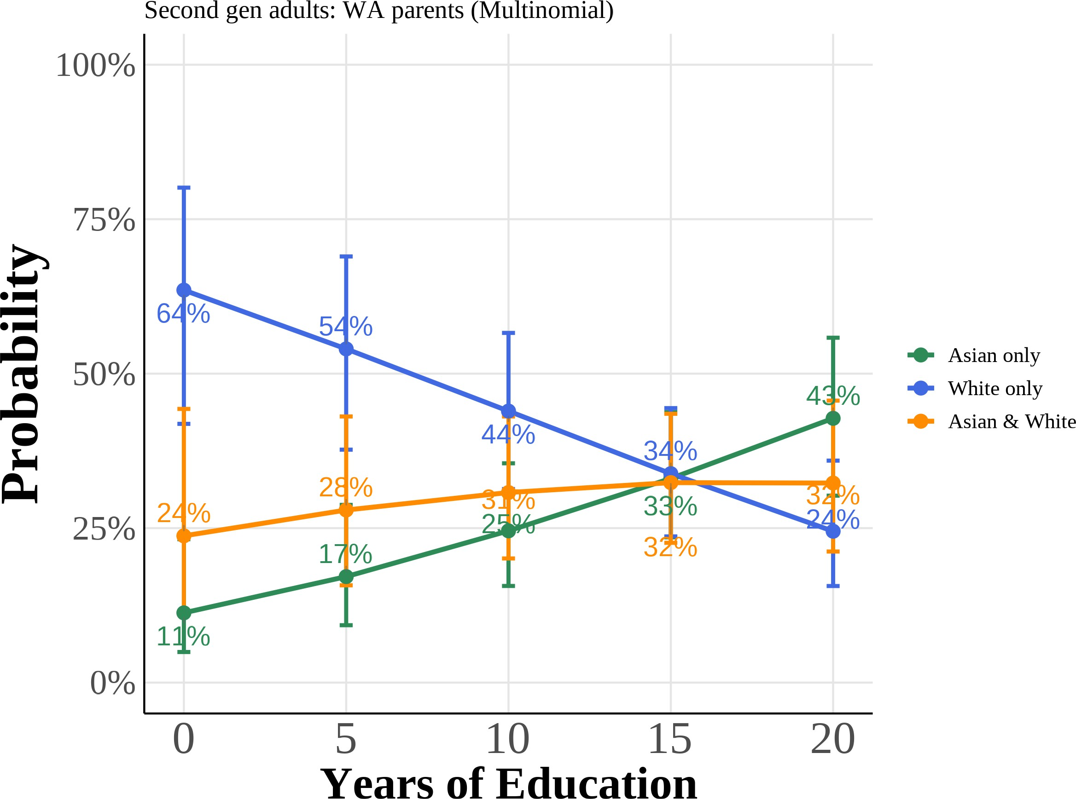

### (c) Log Family Income (AW) (d) Log Family Income (WA)

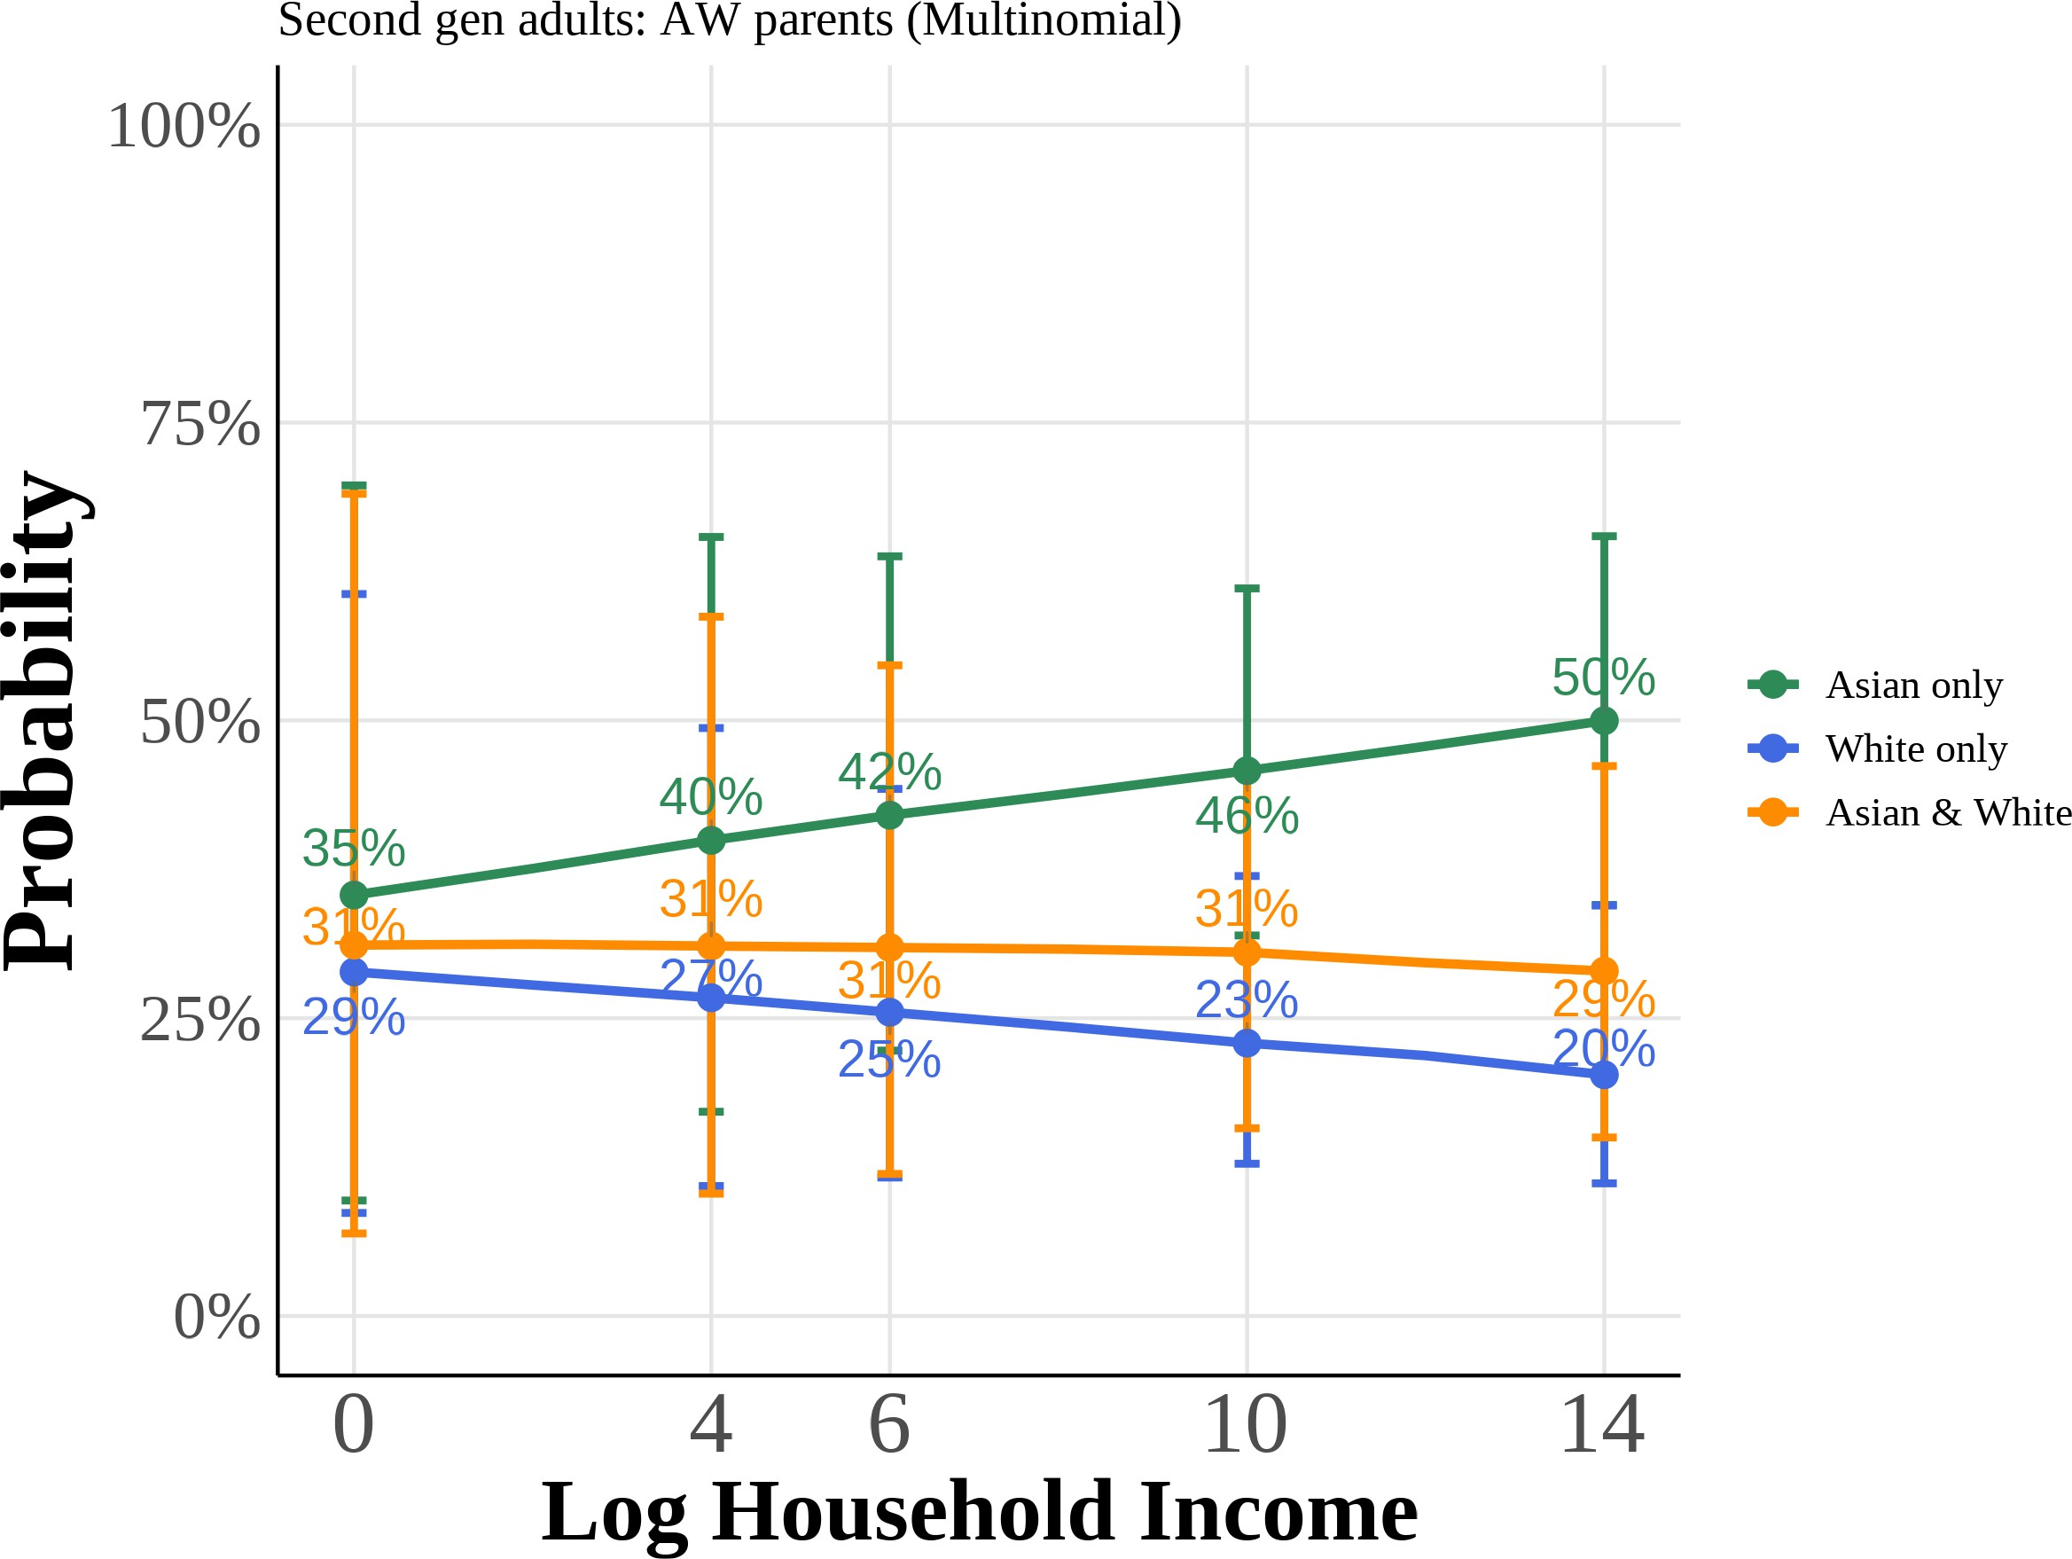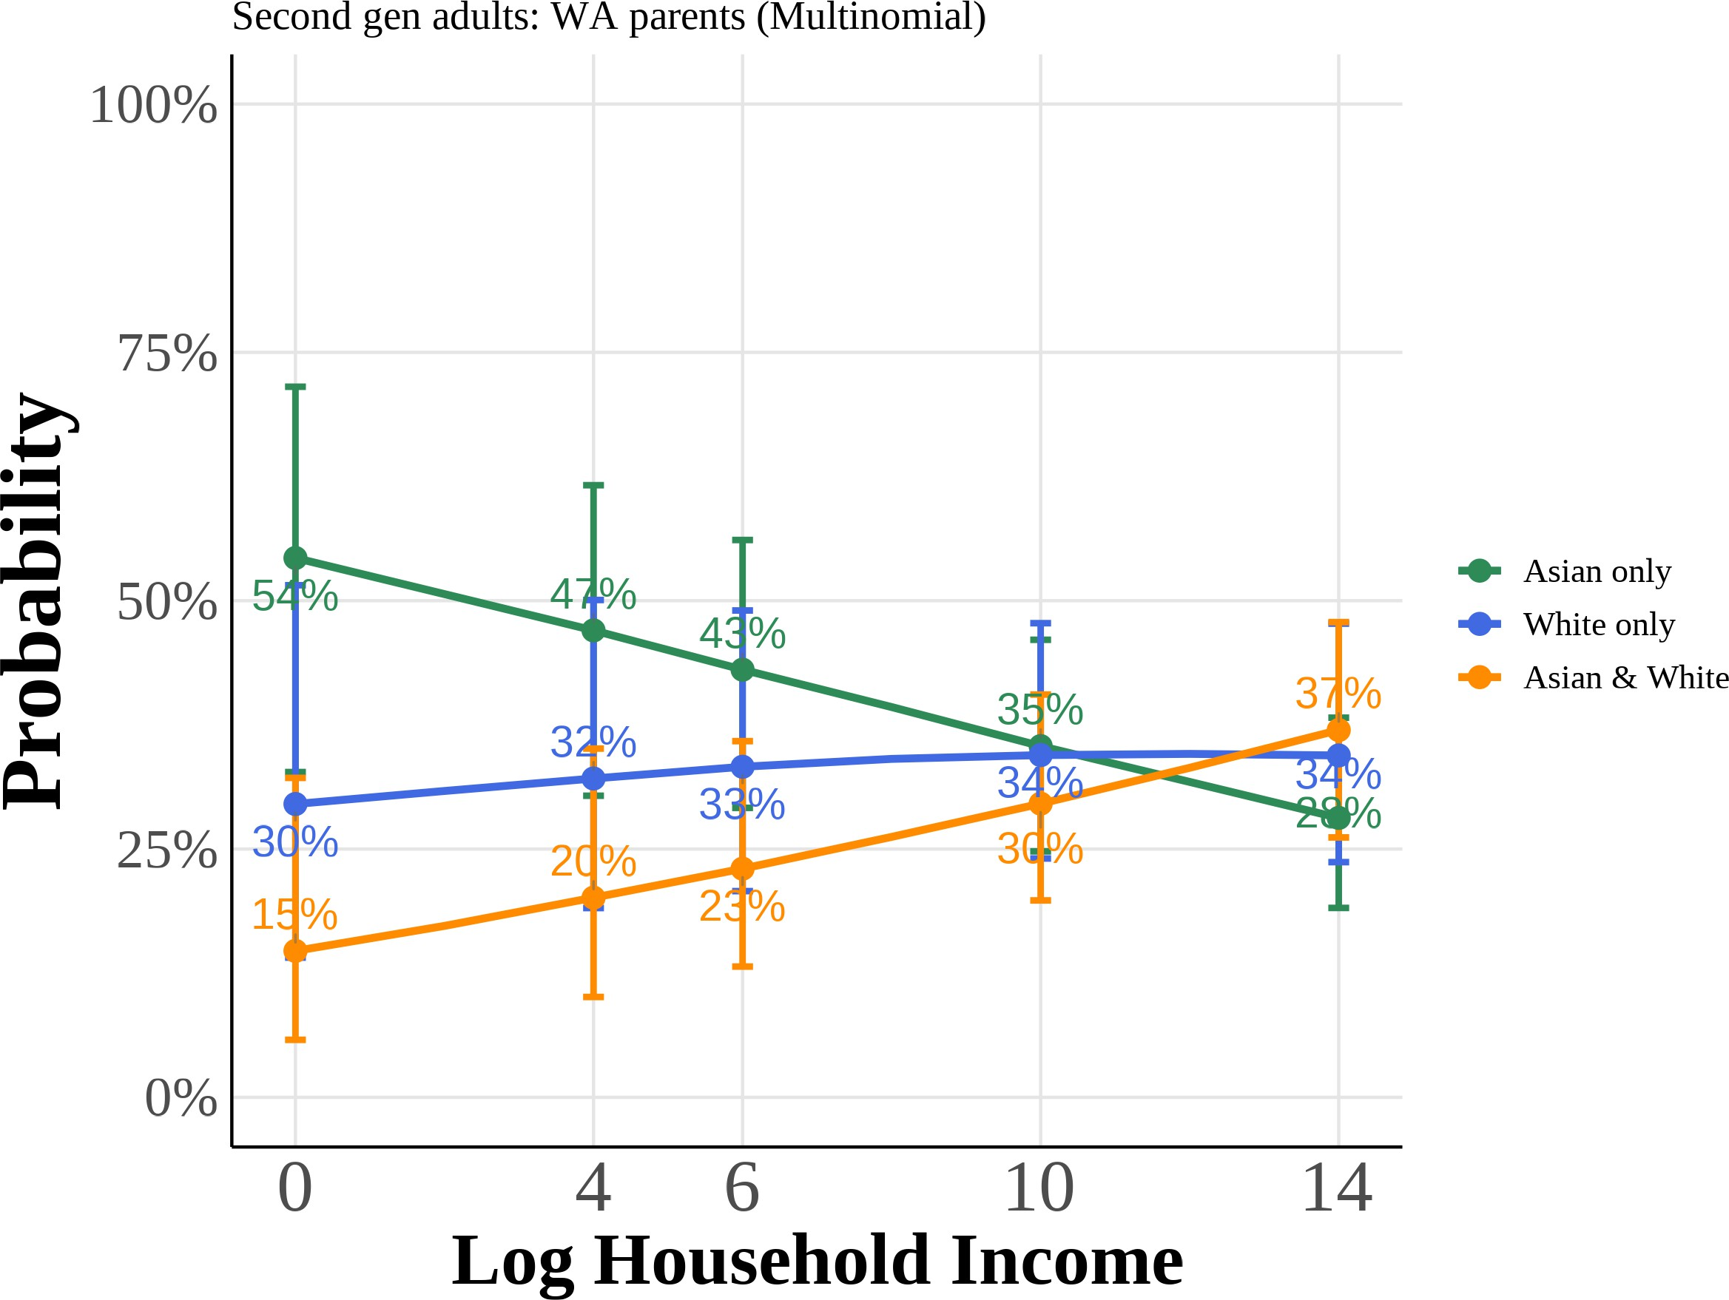

Predicted probabilities from multinomial logit models for second-generation adults with Asian father/White mother (AW) and White father/Asian mother (WA). Each panel shows the probabil-ity of choosing each racial identity as a function of total years of education or log family income, holding other covariates at their means. Curves plot the median predicted probability across 1,000 bootstrap resamples, with 95% confidence intervals given by the bootstrap percentile bounds.

Figure A.12: Multinomial Logit Model: Predicted Probabilities of Racial Identity Choice by Key Covariates (Third-Generation Asian Americans with One Asian Grandparent)

### (a) Anti-Asian Bias (b) Female

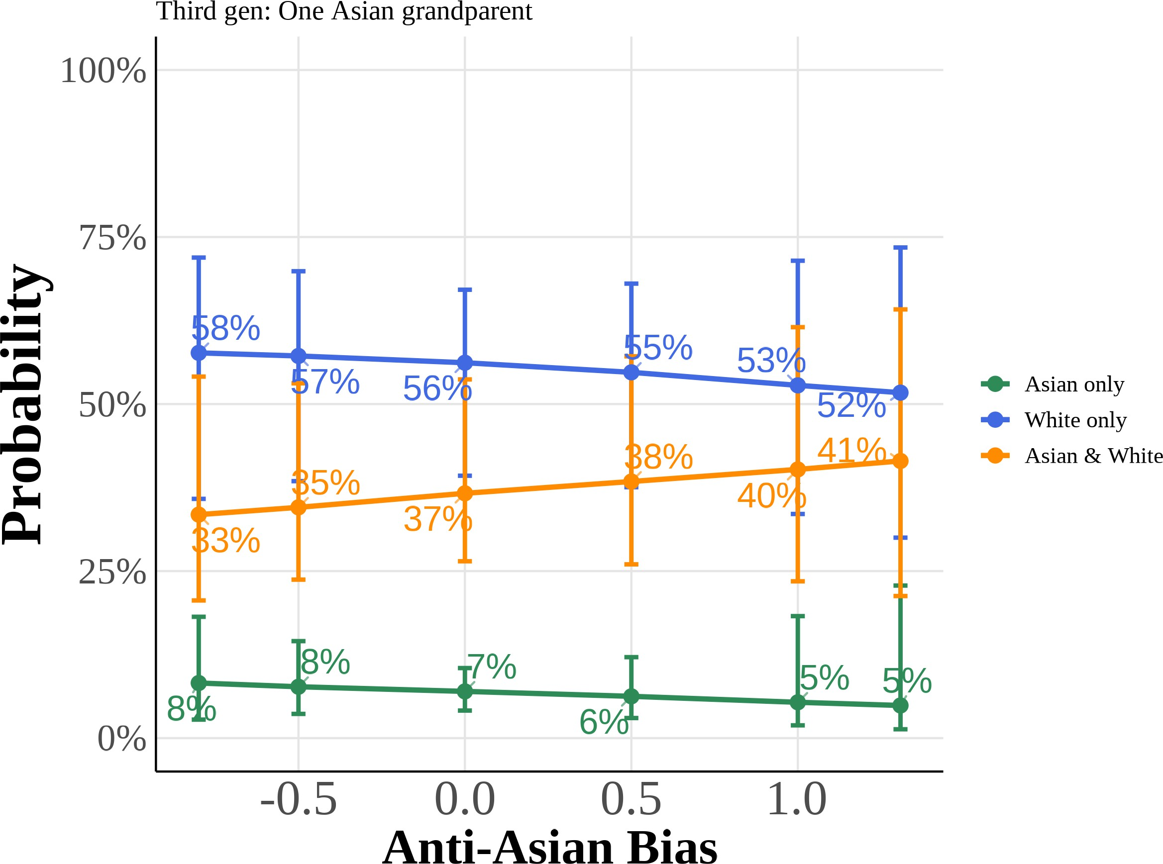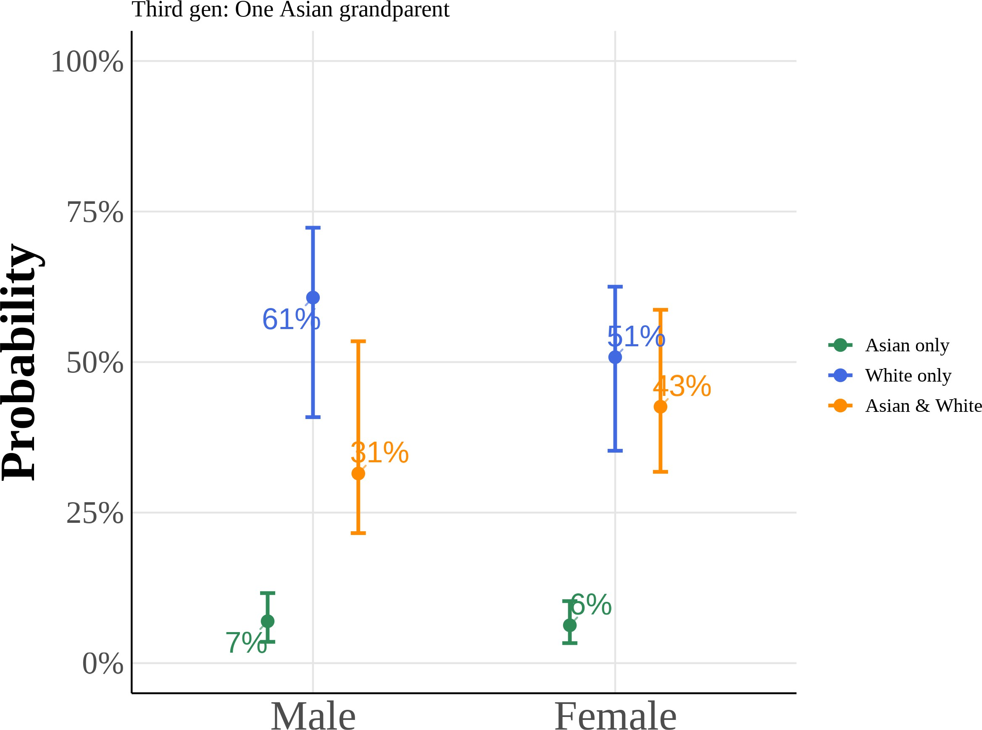

### (c) College Graduate: Mother (d) College Graduate: Father

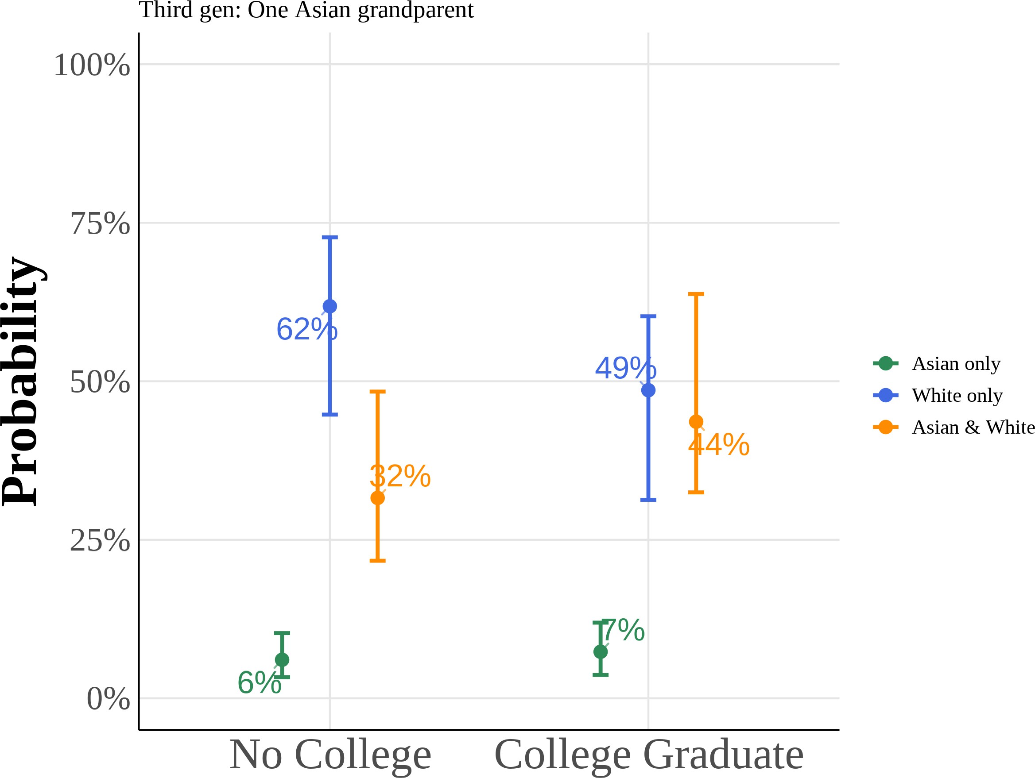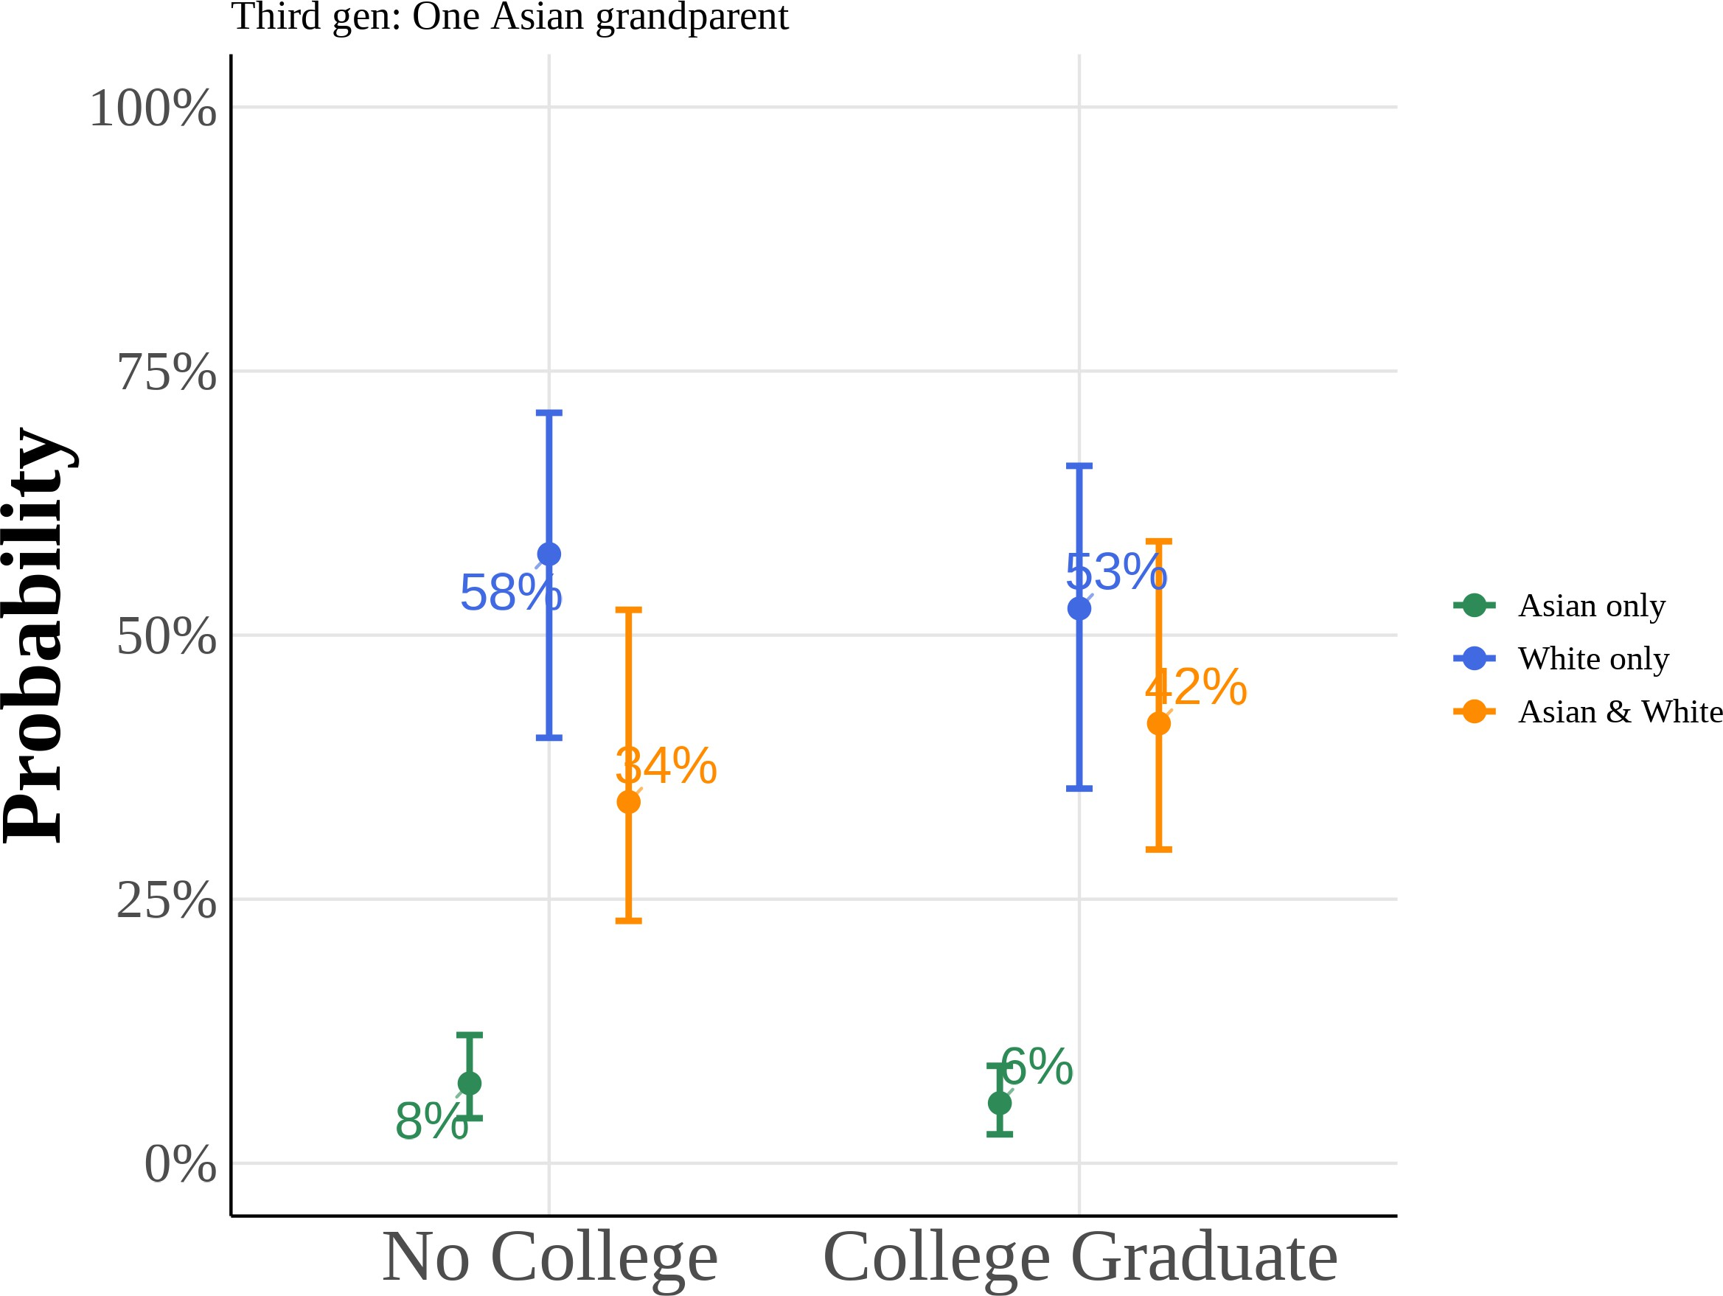

This figure shows predicted probabilities from estimating equation (5) using a multinomial logit model for the subsample of third-generation Asian Americans with one Asian grandparent. The model estimates the probability of choosing “Asian only”, “White only”, or “Asian and White” racial identification as a function of anti-Asian bias, gender, and parental education. I include region *→* year fixed effects with controls for quartic age and local Asian population share. All other variables are held at their sample means. Reported curves depict the median predicted probability across 1,000 bootstrap resamples, with 95% percentile confidence intervals from the same draws.

Figure A.14: Scatter Plot of Proportion Subjectively Asian on Bias

(a) Year < 2015

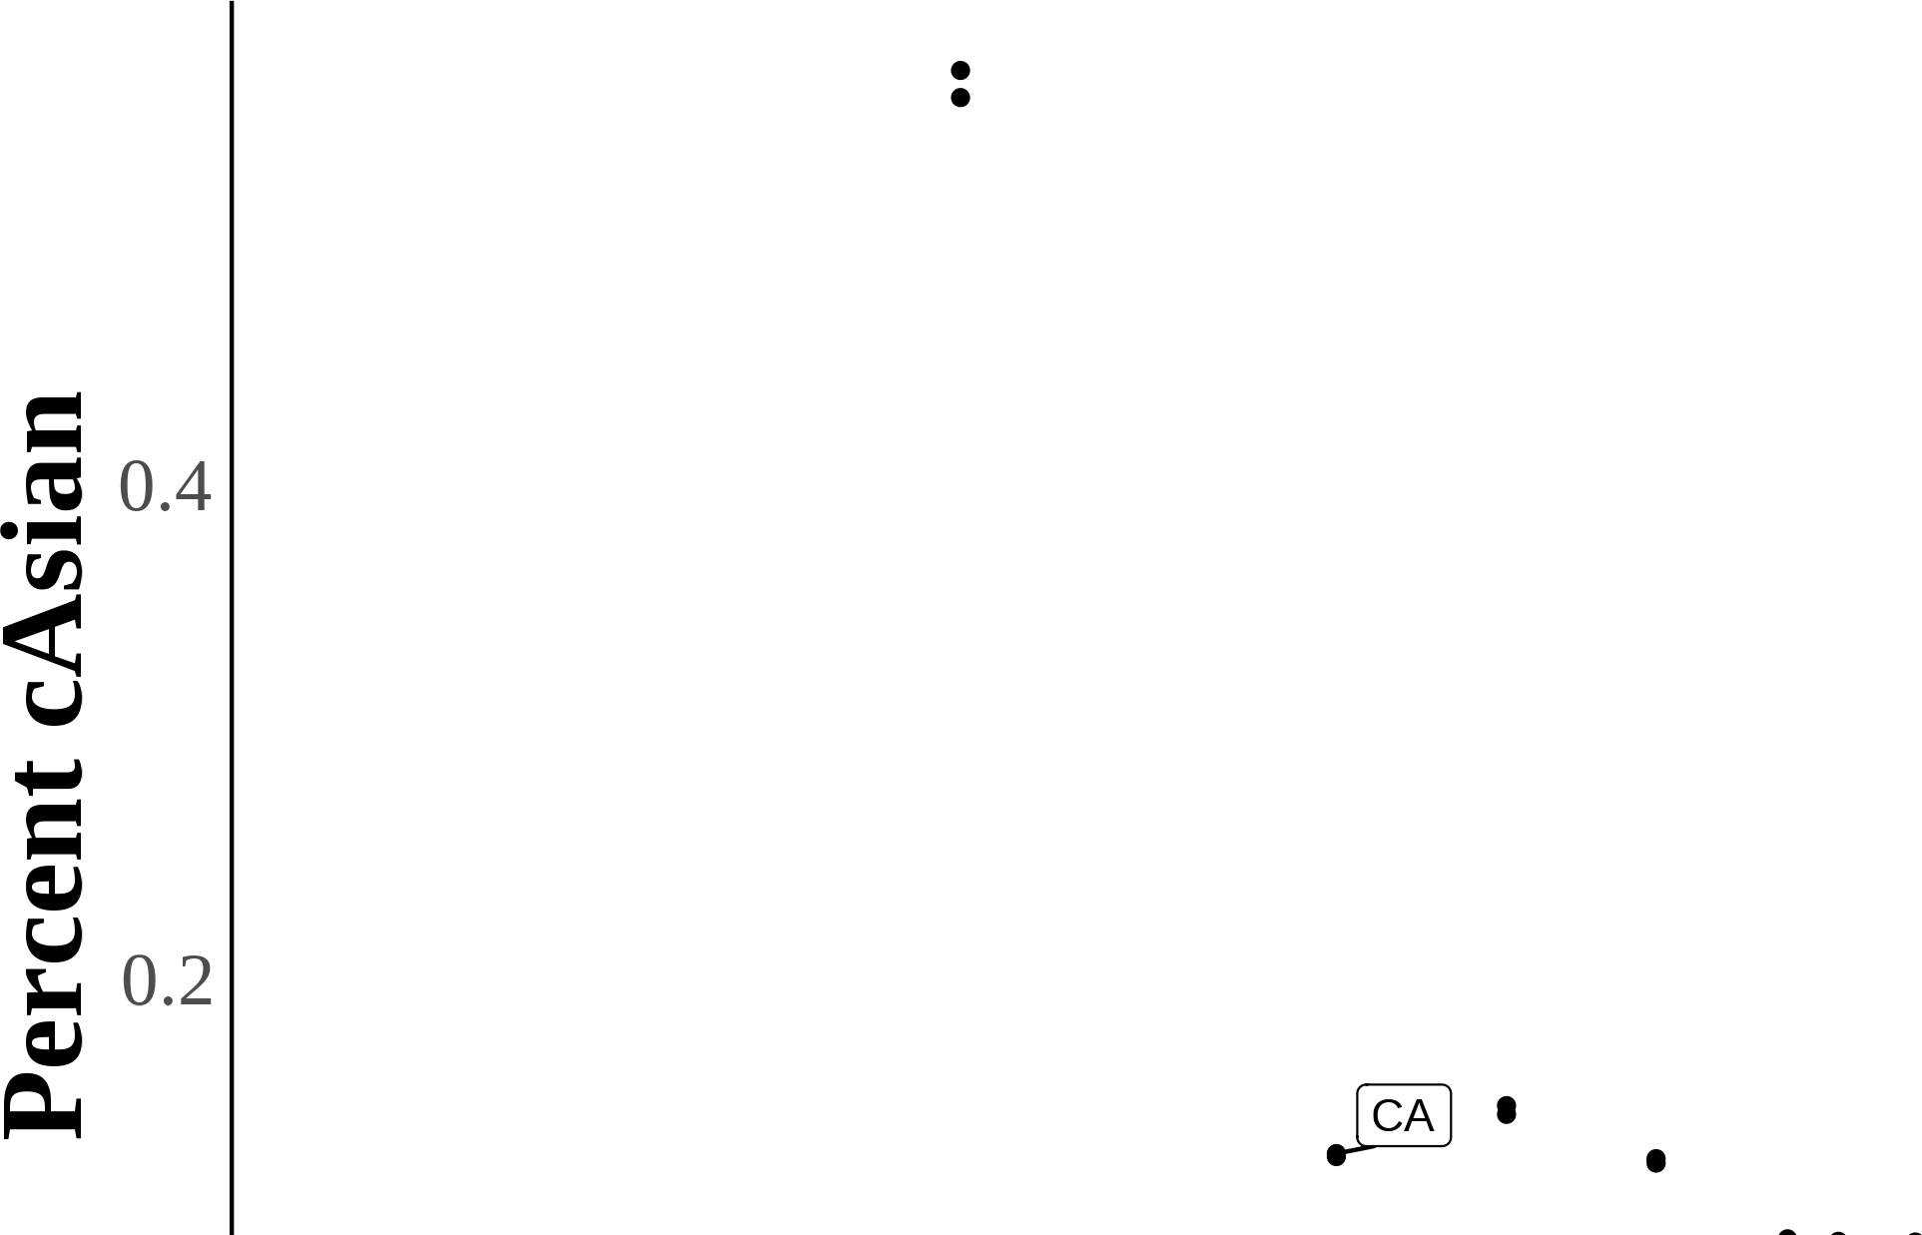

44

Figure A.13: Multinomial Logit Model: Predicted Probabilities of Racial Identity Choice by Key Covariates (Third-Generation Asian Americans with Two Asian Grandparents)

### (a) Anti-Asian Bias (b) Female

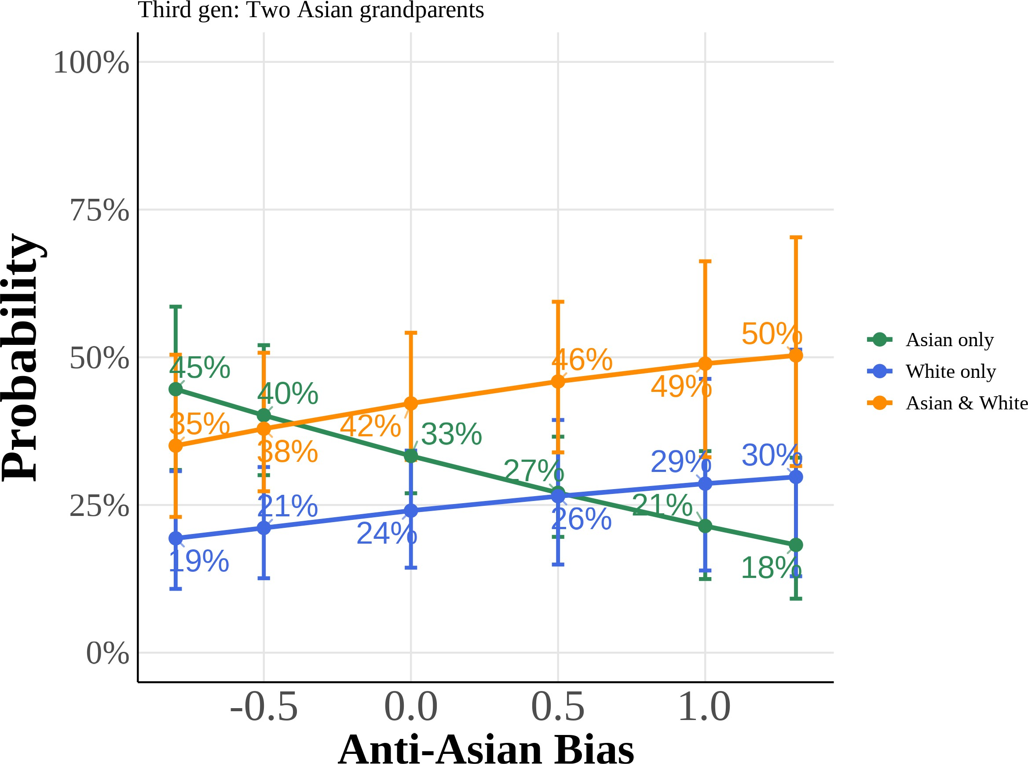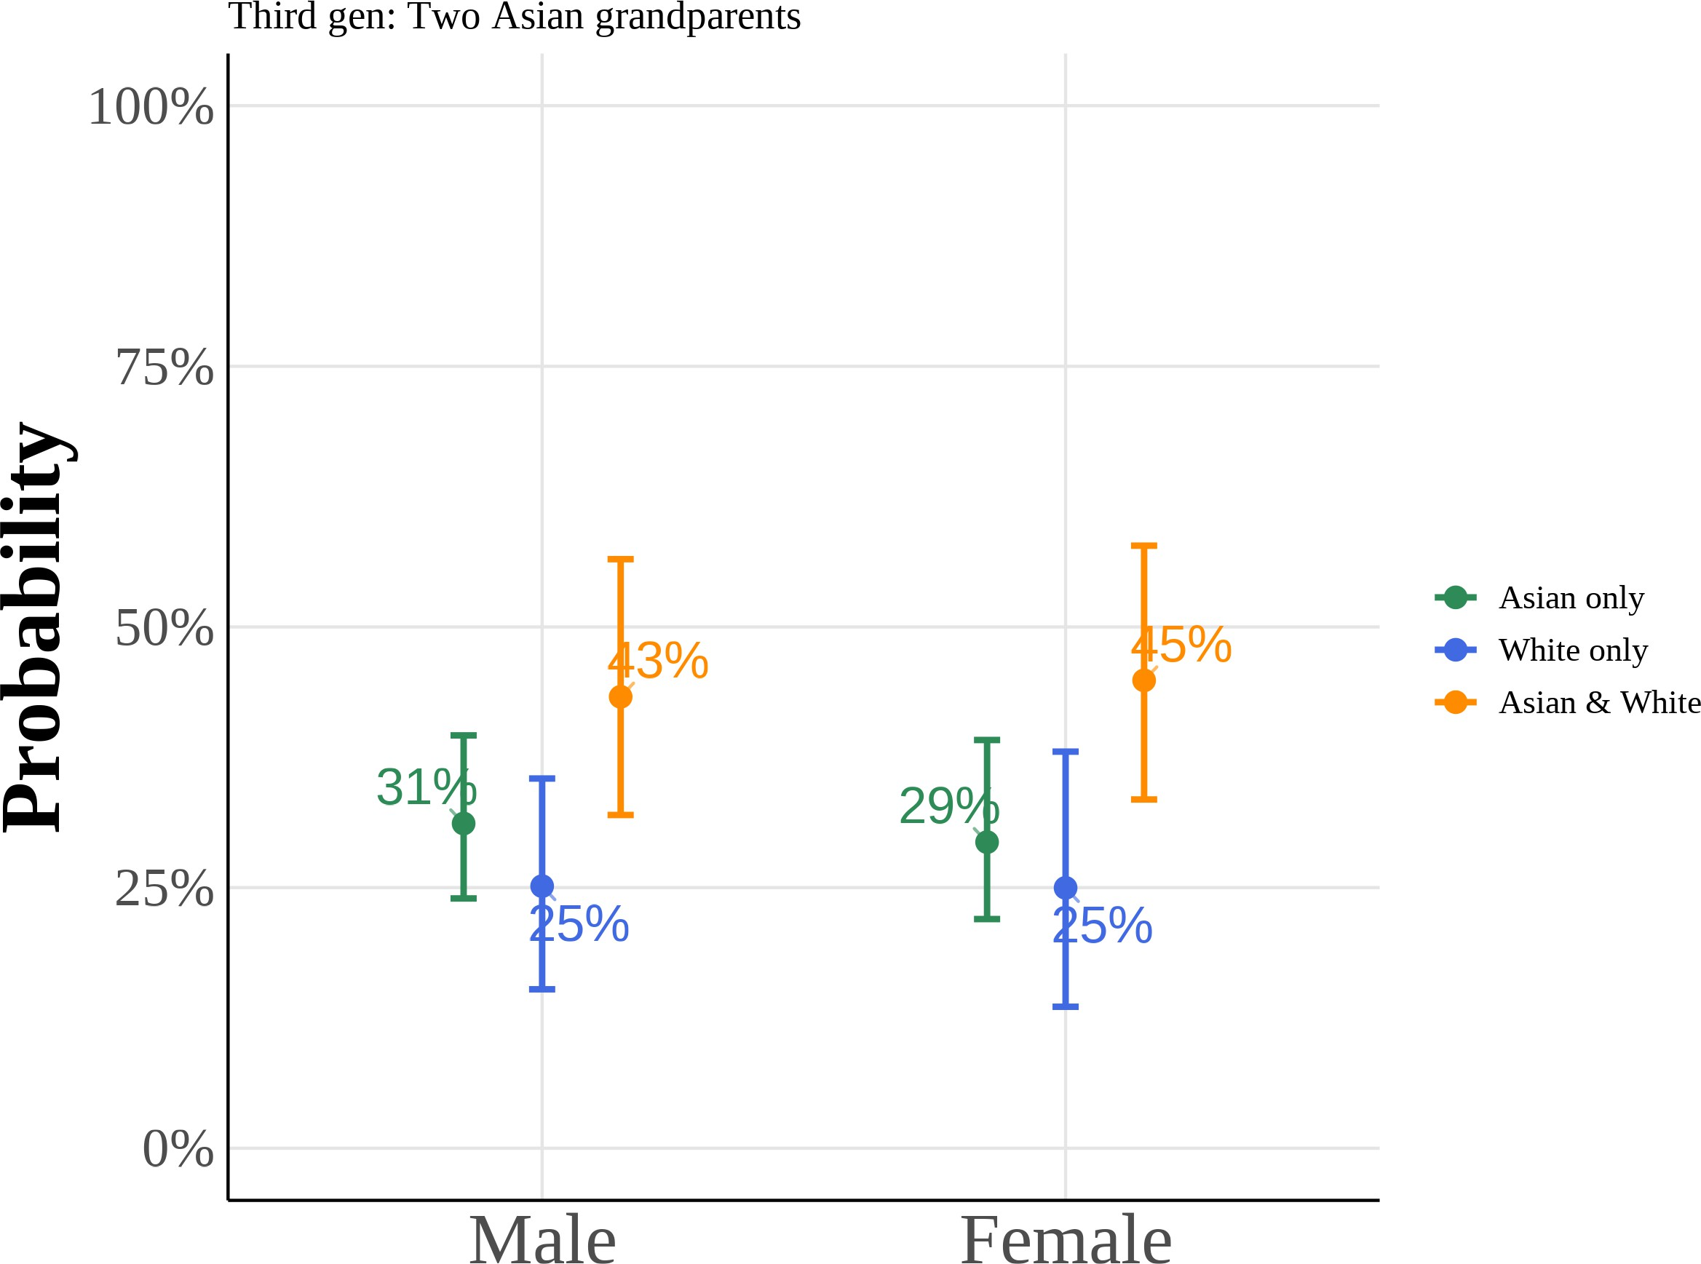

### (c) College Graduate: Mother (d) College Graduate: Father

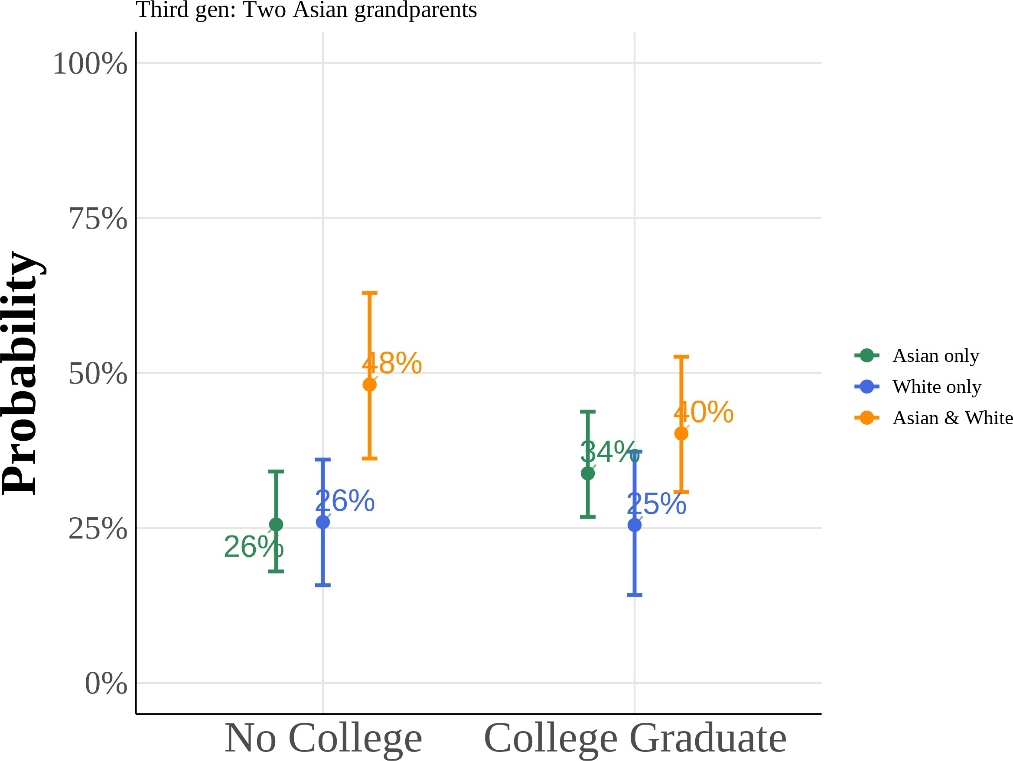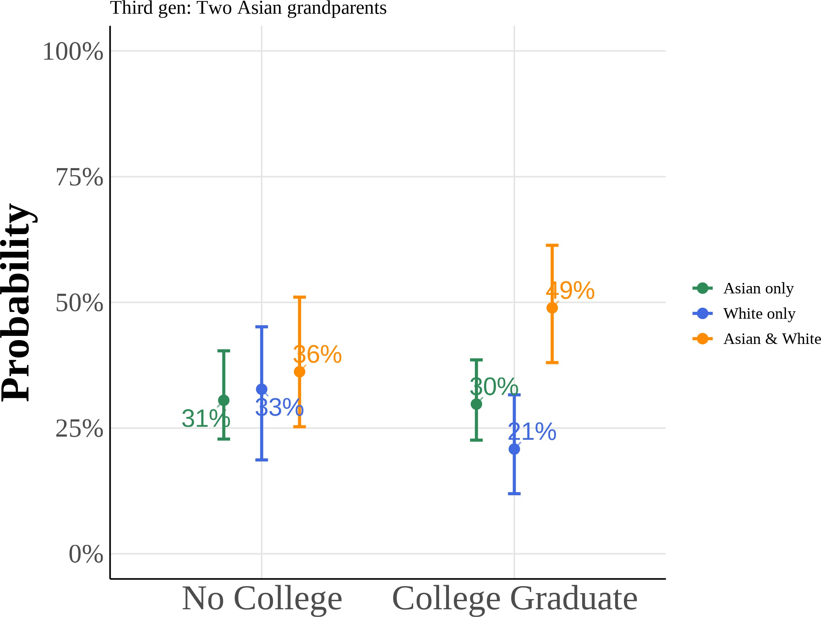

This figure shows predicted probabilities from estimating equation (5) using a multinomial logit model for the subsample of third-generation Asian Americans with two Asian grandparents. The model estimates the probability of choosing “Asian only”, “White only”, or “Asian and White” racial identification as a function of anti-Asian bias, gender, and parental education. I include region *→* year fixed effects with controls for quartic age and local Asian population share. All other variables are held at their sample means. Reported curves depict the median predicted probability across 1,000 bootstrap resamples, with 95% percentile confidence intervals from the same draws.

## Using Lubotsky and Wittenberg (2006) to Construct Bias Index

In Lubotsky and Wittenberg (2006), the authors propose a method to reduce measurement error in proxies by constr4u5cting a composite index. The Lubotsky-

Wittenberg (henceforth LW) consider a model where a covariate is unobserved. Therefore, they use two proxies in its place, which will have measurement error. Thus, the LW method allows researchers to use two proxies that are error-ridden.

LW consider a setup with the following model:

y = ω + εx*↑* + ϑ

x1 = x*↑* + µ1 x2 = x*↑* + µ2

Where x*↑* is the unobserved covariate, x1i and x2i are the proxies, and the mea-surement errors µ1 and µ2 are assumed to be classical and allowed to covary. The covariance matrix of the errors is given by:

i

 σ2 σ12





ϖ = 1

σ12 σ2

2

Replacing the unobserved x*↑* with x1 or x2 yields the following expectations of the OLS estimates:

2

E 'ε1( = ε σ

ˆ x*→*

σ2*→* + σ2

2

; ˆ x*→*

E 'ε2( = ε σ

σ2*→* + σ2

x 1 x 2

Both estimates are biased; the one with the smaller variance of the measure-ment error being less biased.

LW then propose defining a new proxy x3 as a weighted average of x1 and x2:

x3 = λx1 + (1 ! λ)x2

To minimize the attenuation bias in the OLS estimate of ε, they solve for the optimal value of λ:

*↑* σ2 ! σ12

λ = 2 2 2

σ1 + σ2 ! 2σ12

This optimal value of λ is not directly useful because the variances of the mea-surement errors and their covariance are unobserved. However, if you estimate a bivariate regression using OLS (i.e., regress y on x1 and x2), then the expectation of the sum of the two coefficient estimates is identical to the expectation of the OLS coefficient estimate on x3 in a univariate regression using the optimal choice of λ:

E 'εˆ 1 + εˆ 2( = E 'εˆ x3 (

Thus, OLS produces an estimate of ε with the least bias by optimally combin-ing the information in x1 and x2.

# References for Online Appendix

Lubotsky, Darren, and Martin Wittenberg. 2006. “Interpretation of Regressions with Multiple Proxies.” *The Review of Economics and Statistics* 88, no. 3 (Au-gust 1, 2006): 549–562. <https://doi.org/10.1162/rest.88.3.549>.